Chapter 4
The Market Forces of Supply and Demand
MULTIPLE CHOICE
1. The forces that make market economies work are
a. price and quantity.
b. demand and supply.
c. the Senate and House of Representatives.
d. the Constitution and the Bill of Rights.
ANSWER: b. demand and supply.
TYPE: M SECTION: 1 DIFFICULTY: 1
2. Which of the following are the words most commonly used by economists?
a. surplus and shortage
b. scarcity and human wants
c. supply and demand
d. price and quantity
ANSWER: c. supply and demand
TYPE: M SECTION: 1 DIFFICULTY: 1
3. One result of a drought in the midwest could be an increase in
a. farm machinery prices.
b. the price of diesel fuel used in farming.
c. migrant farm workers’ wages.
d. the price of frosted shredded wheat.
ANSWER: d. the price of frosted shredded wheat.
TYPE: M SECTION: 1 DIFFICULTY: 2
4. In a free market, who determines how much of a good will be sold and the price at which it is sold?
a. suppliers
b. demanders
c. the government
d. suppliers and demanders together
ANSWER: d. suppliers and demanders together
TYPE: M SECTION: 1 DIFFICULTY: 1
5. A market is a
a. group of demanders and suppliers of a particular good or service.
b. group of people with common desires.
c. place where only sellers meet.
d. place where only buyers come together.
ANSWER: a. group of demanders and suppliers of a particular good or service.
TYPE: M SECTION: 1 DIFFICULTY: 1
6. The behavior of people as they interact with one another in markets is referred to as
a. economics.
b. interaction.
c. demand and supply.
d. social psychology.
ANSWER: c. demand and supply.
TYPE: M SECTION: 1 DIFFICULTY: 1
7. Which of the following is true?
a. Buyers determine supply and sellers determine demand.
b. Buyers determine demand and sellers determine supply.
c. Buyers and sellers as one group determine supply.
d. Buyers and sellers as one group determine demand.
ANSWER: b. Buyers determine demand and sellers determine supply.
TYPE: M SECTION: 1 DIFFICULTY: 2
8. For each good produced in a market economy, demand and supply determine
a. the price of the good, but not the quantity.
b. the quantity of the good, but not the price.
c. both price and quantity.
d. neither price nor quantity is determined by demand and supply, because prices are ultimately set by producers.
ANSWER: c. both price and quantity.
TYPE: M SECTION: 1 DIFFICULTY: 2
9. In a market economy,
a. demand is determined by supply.
b. supply is determined by demand.
c. price is determined by quantity.
d. quantity is determined by price.
e. Either a or b are correct, depending on the product.
ANSWER: d. quantity is determined by price.
TYPE: M SECTION: 1 DIFFICULTY: 2
10. Who is it that ultimately determines the demand for a product or service?
a. those who buy the product or service
b. the government
c. the producers who create the product or service
d. those who supply the raw materials used in the production of the good or service
ANSWER: a. those who buy the product or service
TYPE: M SECTION: 1 DIFFICULTY: 2
11. An economy’s scarce resources are allocated by
a. economic planners.
b. producers who use resources.
c. prices for resources.
d. government regulation of scarce resources.
ANSWER: c. prices for resources.
TYPE: M SECTION: 1 DIFFICULTY: 2
12. A competitive market is one in which
a. there is only one seller of the product.
b. each seller of the product is free to set the price of his product.
c. each seller attempts to compete with other sellers, causing fewer sellers in the market.
d. there are so many buyers and many sellers that each has a negligible impact on price.
ANSWER: d. there are so many buyers and many sellers so that each has a negligible impact on price.
TYPE: M SECTION: 1 DIFFICULTY: 2
13. In a competitive market,
a. only a few sellers sell the same product.
b. each seller has limited control over the price of his product.
c. if one buyer chooses to purchase a large quantity of the product, the price will rise.
d. if one seller withholds his product from the market, prices will rise.
ANSWER: b. each seller has limited control over the price of his product.
TYPE: M SECTION: 1 DIFFICULTY: 2
14. In a competitive market, each seller has limited control over the price of his product because
a. other sellers are offering similar products.
b. in competitive markets, buyers have more influence over price than sellers.
c. the products sold in competitive markets are generally in abundant supply.
d. sellers in competitive markets prefer to meet and set a price that each will profit from.
ANSWER: a. other sellers are offering similar products.
TYPE: M SECTION: 1 DIFFICULTY: 2
15. For a competitive market, which of the following is true?
a. A seller who charges more than the going price can increase her profit.
b. If a seller charges more than the going price, buyers will go elsewhere.
c. A seller often charges less than the going price to increase sales and profit.
d. A buyer can influence the price of the product, but only when purchasing from several sellers.
ANSWER: b. If a seller charges more than the going price, buyers will go elsewhere.
TYPE: M SECTION: 1 DIFFICULTY: 2
16. Which of the following is NOT a characteristic of a perfectly competitive market?
a. similar products
b. numerous sellers
c. market power
d. numerous buyers
ANSWER: c. market power
TYPE: M SECTION: 1 DIFFICULTY: 1
17. Price takers refer to buyers and sellers in
a. a perfectly competitive market.
b. a monopolisticly competitive market.
c. an oligopolistic market.
d. a monopolistic market.
ANSWER: a. a perfectly competitive market.
TYPE: M SECTION: 1 DIFFICULTY: 2
18. Buyers and sellers who have no influence on market price are referred to as
a. price makers.
b. market pawns.
c. price takers.
d. powerless.
ANSWER: c. price takers.
TYPE: M SECTION: 1 DIFFICULTY: 1
19. Price takers have no influence over market prices because there are
a. numerous buyers.
b. numerous sellers.
c. distinctive products.
d. Both a and b are correct.
ANSWER: d. Both a and b are correct.
TYPE: M SECTION: 1 DIFFICULTY: 1
20. An example of a perfectly competitive market would be the
a. cable TV market.
b. soybean market.
c. new car market.
d. blue jean market.
ANSWER: b. soybean market.
TYPE: M SECTION: 1 DIFFICULTY: 2
21. Generally, the market for ice cream would be considered
a. a monopolistic market.
b. a competitive market.
c. more organized than an auction.
d. a market where individual sellers have significant pricing power.
ANSWER: b. a competitive market.
TYPE: M SECTION: 1 DIFFICULTY: 1
22. If a seller in a competitive market chooses to charge more than the market price, then
a. buyers would tend to buy more from this seller.
b. the owners of the raw materials used in production would raise the prices for the raw materials.
c. other sellers would also raise their price.
d. buyers will tend to make purchases from other sellers.
ANSWER: d. buyers will tend to make purchases from other sellers.
TYPE: M SECTION 1 DIFFICULTY: 2
23. If buyers and/or sellers are price takers, then individually
a. they have no influence on market price.
b. they have ultimate control over market price.
c. buyers will be able to find prices lower than those determined in the market.
d. they can somewhat influence the market price.
ANSWER: a. they have no influence on market price.
TYPE: M SECTION 1 DIFFICULTY: 2
24. There are thousands of wheat farmers who produce and sell wheat and there are millions of consumers who use wheat and wheat products. The market for wheat would be considered
a. oligopolistic.
b. monopolistic.
c. perfectly competitive.
d. monopolistically competitive.
ANSWER: c. perfectly competitive.
TYPE: M SECTION: 1 DIFFICULTY: 1
25. As a seller, you would be considered part of a perfectly competitive market if
a. your actions are quickly followed by competitors.
b. your actions essentially have no effect on the market price.
c. your pricing has no impact on the amount you can sell.
d. increases in the price of your product have an impact on the market price.
ANSWER: b. your actions essentially have no effect on the market price.
TYPE: M SECTION: 1 DIFFICULTY: 2
26. Rank the 4 market types from most to least number of firms.
a. Monopoly, perfect competitive, monopolistic competitive, oligopoly.
b. Perfect competitive, oligopoly, monopolistic competitive, monopoly.
c. Monopoly, oligopoly, monopolistic competitive, perfect competitive.
d. Perfect competitive, monopolistic competitive, oligopoly, monopoly.
ANSWER: d. Perfect competitive, monopolistic competitive, oligopoly, monopoly.
TYPE: M SECTION: 1 DIFFICULTY: 2
27. A monopoly is a market
a. with one seller.
b. with few sellers.
c. with one buyer.
d. where the government sets the price.
ANSWER: a. with one seller.
TYPE: M SECTION: 1 DIFFICULTY: 1
28. Which of the following would be an example of a monopoly?
a. a bakery in a large city
b. local cement companies
c. a local cable television company
d. a potato farmer
ANSWER: c. a local cable television company
TYPE: M SECTION: 1 DIFFICULTY: 1
29. A market with only a few sellers would be
a. a monopoly.
b. an oligopoly.
c. a competitive market.
d. a monopolistically competitive market.
ANSWER: b. an oligopoly.
TYPE: M SECTION: 1 DIFFICULTY: 1
30. Which of the following would be an example of an oligopolistic market?
a. the air travel industry
b. the domestic wheat market
c. the software industry
d. electrical power for residential consumers
ANSWER: a. the air travel industry
TYPE: M SECTION: 1 DIFFICULTY: 1
31. A market with many sellers offering similar but slightly different products is called
a. a monopoly.
b. oligopolistic.
c. monopolistically competitive.
d. perfectly competitive.
ANSWER: c. monopolistically competitive.
TYPE: M SECTION: 1 DIFFICULTY: 1
32. One characteristic of a monopolistically competitive market is that there
a. is a single seller of the product.
b. are a few sellers that do not always compete aggressively.
c. are many buyers and sellers of an identical product.
d. is a large number of sellers all offering similar but different products.
ANSWER: d. a large number of sellers all offering similar but different products.
TYPE: M SECTION: 1 DIFFICULTY: 1
33. An example of a monopolistically competitive market would be the
a. farming industry.
b. cable television industry.
c. software industry.
d. car repair industry.
ANSWER: c. software industry.
TYPE: M SECTION: 1 DIFFICULTY: 1
34. If a seller is supplying a product that is slightly different from that of many close competitors and is able to charge a different price than competitors, then the seller
a. is a monopolist.
b. is participating in a monopolistically competitive market.
c. will eventually have to decrease the price.
d. is producing a homogeneous product.
ANSWER: b. is participating in a monopolistically competitive market.
TYPE: M SECTION: 1 DIFFICULTY: 2
35. The behavior of buyers is represented by
a. demand.
b. supply.
c. a market.
d. competition.
ANSWER: a. demand.
TYPE: M SECTION: 2 DIFFICULTY: 1
36. Which of the following would NOT be a determinant of demand?
a. the price of related goods
b. income
c. tastes
d. the prices of the inputs used to produce the good
ANSWER: d. the prices of the inputs used to produce the good
TYPE: M SECTION: 2 DIFFICULTY: 1
37. Each of the following are determinants of demand EXCEPT
a. tastes.
b. technology.
c. income.
d. the price of related goods.
ANSWER: b. technology.
TYPE: M SECTION: 2 DIFFICULTY: 1
38. The amount of the good buyers are willing and able to purchase is the
a. demand.
b. quantity supplied.
c. quantity demanded.
d. supply.
ANSWER: c. quantity demanded.
TYPE: M SECTION: 2 DIFFICULTY: 2
39. If a good is “normal,” then an increase in income will result in
a. no change in the demand for the good.
b. an increase in the demand for the good.
c. a decrease in the demand for the good.
d. a lower market price.
ANSWER: b. an increase in the demand for the good.
TYPE: M SECTION: 2 DIFFICULTY: 2
40. If Francis receives a decrease in his pay, we would expect
a. Francis’s demand for each good he purchases to remain unchanged.
b. Francis’s demand for normal goods to increase.
c. Francis’s demand for luxury goods to increase.
d. Francis’s demand for inferior goods to increase.
ANSWER: d. Francis’s demand for inferior goods to increase.
TYPE: M SECTION: 2 DIFFICULTY: 2
41. A good is considered either a normal good or an inferior good based on
a. the quality of the good.
b. the price of the good.
c. personal preference toward the good.
d. the amount of a person’s income.
ANSWER: c. personal preference toward the good.
TYPE: M SECTION: 2 DIFFICULTY: 2
42. You lose your job and as a result you buy fewer mystery books. This shows that you consider mystery books to be a/an
a. normal good.
b. inferior good.
c. luxury good.
d. complementary good.
ANSWER: a. normal good.
TYPE: M SECTION: 2 DIFFICULTY: 2
43. Currently you purchase 6 packages of hot dogs a month. You will be graduating in December and will start your new job January 2nd. You have no plans to purchase hot dogs in January. For you, hot dogs are
a. a “college-only” good.
b. a normal good.
c. an inferior good.
d. a consumer good.
ANSWER: c. an inferior good.
TYPE: M SECTION: 2 DIFFICULTY: 2
44. An example of an inferior good might be
a. neckties.
b. Ramen noodles.
c. cloth napkins.
d. cut flowers.
ANSWER: b. Ramen noodles.
TYPE: M SECTION: 2 DIFFICULTY: 1
45. If the price of a substitute to good X increases, then the
a. demand for good X will decrease.
b. market price of good X will decrease.
c. demand for good X will increase.
d. quantity demanded for good X will increase.
ANSWER: c. demand for good X will increase.
TYPE: M SECTION: 2 DIFFICULTY: 2
46. Suppose that a decrease in the price of X results in less of good Y sold. This would mean that X and Y are
a. complementary goods.
b. normal goods.
c. inferior goods.
d. substitute goods.
ANSWER: d. substitute goods.
TYPE: M SECTION: 2 DIFFICULTY: 3
47. Two goods are substitutes if a decrease in the price of one good
a. increases the demand for the other good.
b. reduces the demand for the other good.
c. reduces the quantity demanded of the other good.
d. increases the quantity demanded of the other good.
ANSWER: b. reduces the demand for the other good.
TYPE: M SECTION: 2 DIFFICULTY: 3
48. Two goods are complements if a decrease in the price of one good
a. increases the quantity demanded of the other good.
b. reduces the demand for the other good.
c. reduces the quantity demanded of the other good.
d. raises the demand for the other good.
ANSWER: d. raises the demand for the other good.
TYPE: M SECTION: 2 DIFFICULTY: 3
49. An example of complementary goods would be
a. hamburgers and hot dogs.
b. lawnmowers and automobiles.
c. hamburgers and fries.
d. Coke and Pepsi.
ANSWER: c. hamburgers and fries.
TYPE: M SECTION: 2 DIFFICULTY: 2
50. If goods A and B are complements, an increase in the price of A will result in
a. more of good A sold.
b. more of good B sold.
c. less of good B sold.
d. no difference in the quantity sold of either good.
ANSWER: c. less of good B sold.
TYPE: M SECTION: 2 DIFFICULTY: 2
51. An example of substitute goods would be
a. butter and margarine.
b. tennis balls and tennis rackets.
c. televisions and tractors.
d. peanut butter and jelly.
ANSWER: a. butter and margarine.
TYPE: M SECTION: 2 DIFFICULTY: 2
52. For economists, people’s tastes and demand are
a. beyond the realm of economics.
b. negatively related.
c. not related.
d. positively related.
ANSWER: d. positively related.
TYPE: M SECTION: 2 DIFFICULTY: 2
53. When it comes to people’s tastes, economists generally believe that
a. tastes are based on forces beyond the realm of economics.
b. tastes are based on historical and psychological forces.
c. tastes can only be studied through well-constructed, real-life models.
d. since tastes do not directly affect demand, there is little need to explain people’s tastes.
ANSWER: b. tastes are based on historical and psychological forces.
TYPE: M SECTION: 2 DIFFICULTY: 2
54. Economists in general
a. do not try to explain people’s tastes, but do try to explain what happens when tastes change.
b. must be able to explain people’s tastes to explain what happens when tastes change.
c. do not believe that people’s tastes determine demand and therefore ignore the subject of tastes.
d. believe that tastes and demand move in opposite directions.
ANSWER: a. do not try to explain people’s tastes, but do try to explain what happens when tastes change.
TYPE: M SECTION: 2 DIFFICULTY: 2
55. A person’s expectations about the future
a. cannot affect demand because expectations change.
b. can affect future demand.
c. can affect current demand.
d. cannot shift a demand curve.
ANSWER: c. can affect current demand.
TYPE: M SECTION: 2 DIFFICULTY: 2
56. You love peanut butter. You hear on the news that 50 % of the peanut crop in the South has been wiped out, which will cause the price to double by the end of the year. As a result,
a. your demand for peanut butter will increase by the end of the year.
b. your demand for peanut butter increases today.
c. your demand for peanut butter falls as you look for a substitute good.
d. you decide to give up peanut butter completely.
ANSWER: b. your demand for peanut butter increases today.
TYPE: M SECTION: 2 DIFFICULTY: 2
57. You have decided to purchase a new Mustang convertible. A friend tells you that Ford will be offering a $3000 rebate on Mustangs starting next month. As a result of this information your demand
a. could shift either right or left.
b. for Mustangs shifts right today.
c. curve will be unaffected.
d. for Mustangs shifts left today.
ANSWER: d. for Mustangs shifts left today.
TYPE: M SECTION: 2 DIFFICULTY: 2
58. Suppose you like banana cream pie made with vanilla pudding. Assuming all other things are constant, you notice that the price of bananas is higher. How would your demand for vanilla pudding be affected by this?
a. It would decrease.
b. It would increase.
c. It would be unaffected.
d. There is insufficient information given to answer the question.
ANSWER: a. It would decrease.
TYPE: M SECTION: 2 DIFFICULTY: 2
59. Alyssa rents 5 movies per month when the price is $3.00 each and 7 movies per month when the price is $2.50. Alyssa has demonstrated the
a. law of price.
b. law of supply.
c. actions of an irrational consumer.
d. law of demand.
ANSWER: d. law of demand.
TYPE: M SECTION: 2 DIFFICULTY: 2
60. According to the law of demand price and quantity
a. supplied are inversely related.
b. demanded are inversely related.
c. demanded are positively related.
d. supplied are positively related.
ANSWER: b. demanded are inversely related.
TYPE: M SECTION: 2 DIFFICULTY: 2
61. The law of demand says that when price
a. rises, quantity demanded falls.
b. rises, quantity demanded rises also.
c. falls, quantity supplied rises.
d. falls, quantity supplied falls also.
ANSWER: a. rises, quantity demanded falls.
TYPE: M SECTION: 2 DIFFICULTY: 2
62. Which of the following demonstrates the law of demand?
a. Jon buys more pretzels at $1.50 each since he got a $1 raise at work.
b. Melissa buys fewer muffins at $0.75 each than at $1 each.
c. Dave buys more donuts at $0.25 each than at $0.50 each.
d. Kendra buys fewer Snickers at $0.60 each since the price of Milky Ways fell to $0.50 each.
ANSWER: c. Dave buys more donuts at $0.25 each than at $0.50 each.
TYPE: M SECTION: 2 DIFFICULTY: 2
63. A higher price for batteries would tend to
a. increase the demand for flashlights.
b. increase the demand for electricity.
c. decrease the demand for electricity.
d. increase the demand for batteries.
ANSWER: b. increase the demand for electricity.
TYPE: M SECTION: 2 DIFFICULTY: 2
64. If a decrease in income increases the demand for a good, then the good is
a. a substitute good.
b. a complement good.
c. a normal good.
d. an inferior good.
ANSWER: d. an inferior good.
TYPE: M SECTION: 2 DIFFICULTY: 2
65. Which of the following is NOT a determinant of demand?
a. the price of a resource
b. the price of a complementary good
c. the price of the good next month
d. the price of a substitute good
ANSWER: a. the price of a resource
TYPE: M SECTION: 2 DIFFICULTY: 1
66. What will happen in the rice market if buyers are expecting higher prices in the near future?
a. The demand for rice will increase.
b. The demand for rice will decrease.
c. The demand for rice will be unaffected.
d. The supply of rice will increase.
ANSWER: a. The demand for rice will increase.
TYPE: M SECTION: 2 DIFFICULTY: 2
67. Holding all else constant, a higher price for ski lift tickets would be expected to
a. increase the number of skiers.
b. decrease the supply of ski resorts.
c. decrease the demand for other winter recreational activities.
d. decrease ski sales.
ANSWER: d. decrease ski sales.
TYPE: M SECTION: 2 DIFFICULTY: 2
68. A table that shows the relationship between the price of a good and the quantity demanded is called a
a. demand table.
b. demand schedule.
c. price-quantity table.
d. quantity demanded schedule.
ANSWER: b. demand schedule.
TYPE: M SECTION: 2 DIFFICULTY: 1
69. A demand schedule is a table showing the relationship between
a. the price of a good and the quantity supplied.
b. income and the quantity of the good demanded.
c. the price of a good and the quantity buyers are willing and able to purchase.
d. the determinants of demand and the quantity demanded.
ANSWER: c. the price of a good and the quantity buyers are willing and able to purchase.
TYPE: M SECTION: 2 DIFFICULTY: 1
70. Economists use the term schedule for certain tables because they
a. resemble a train schedule.
b. describe what a consumer/producer is scheduled to do.
c. resemble a scheduled line-up for a sporting event.
d. describe the “schedule of events” for buyers and sellers.
ANSWER: a. resemble a train schedule.
TYPE: M SECTION: 2 DIFFICULTY: 1
71. When referring to the variables price and quantity demanded, price
a. and quantity demanded are independent of each other.
b. is the dependent variable and quantity demanded is the independent variable.
c. is the independent variable and quantity demanded is the dependent variable.
d. and quantity demanded are both dependent variables, since both depend on the actions of buyers and sellers.
ANSWER: c. is the independent variable and quantity demanded is the dependent variable.
TYPE: M SECTION: 2 DIFFICULTY: 3
72. When constructing a demand curve
a. demand is on the vertical axis and quantity is on the horizontal axis.
b. price is on the horizontal axis and quantity is on the vertical axis.
c. price is on the vertical axis and demand is on the horizontal axis.
d. price is on the vertical axis and quantity is on the horizontal axis.
ANSWER: d. price is on the vertical axis and quantity is on the horizontal axis.
TYPE: M SECTION: 2 DIFFICULTY: 1
73. The downward-sloping line which relates prices and quantity demanded is called the
a. demand schedule.
b. demand curve.
c. quantity demanded line.
d. quantity demanded curve.
ANSWER: b. demand curve.
TYPE: M SECTION: 2 DIFFICULTY: 1
74. A demand curve illustrates the
a. tradeoff between inflation and unemployment.
b. positive relationship between price and quantity demanded.
c. negative relationship between price and quantity demanded.
d. maximum quantity of two goods an economy is capable of producing with available resources and technology.
ANSWER: c. negative relationship between price and quantity demanded.
TYPE: M SECTION: 2 DIFFICULTY: 2
75. A demand curve is
a. the downward-sloping line relating the price of the good to the quantity demanded.
b. the upward-sloping line relating price to quantity supplied.
c. the curve that relates income to quantity demanded.
d. showing the same relationship between two goods as a production possibilities frontier.
ANSWER: a. the downward-sloping line relating the price of the good to the quantity demanded.
TYPE: M SECTION: 2 DIFFICULTY: 2
76. The movement from point A to point B on the graph would be caused by
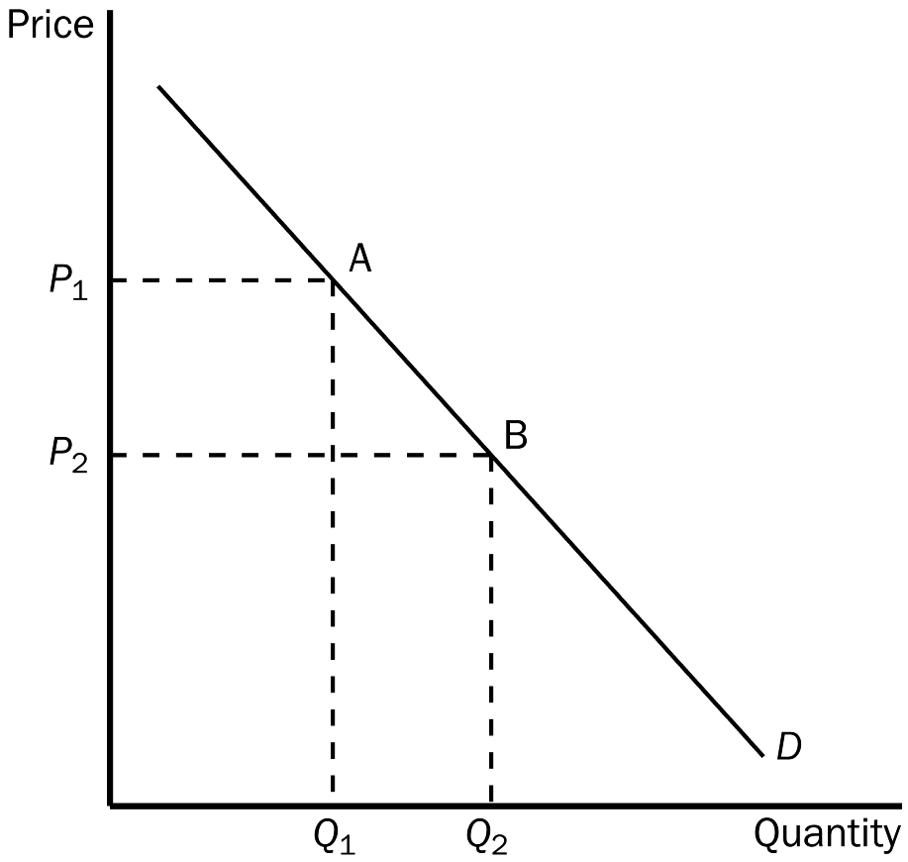
a. an increase in price.
b. a decrease in price.
c. a decrease in the price of a substitute good.
d. an increase in income.
ANSWER: b. a decrease in price.
TYPE: M SECTION: 2 DIFFICULTY: 2
77. The movement from point A to point B on the graph shows
a. a decrease in demand.
b. an increase in demand.
c. a decrease in quantity demanded.
d. an increase in quantity demanded.
ANSWER: d. an increase in quantity demanded.
TYPE: M SECTION: 2 DIFFICULTY: 2
78. When we move up or down a given demand curve,
a. only price is held constant.
b. income and the price of the good are held constant.
c. all nonprice determinants of demand are assumed to be constant.
d. all determinants of quantity demanded are held constant.
ANSWER: c. all nonprice determinants of demand are assumed to be constant.
TYPE: M SECTION: 2 DIFFICULTY: 3
79. Which of the following would NOT shift the demand curve for a good or service?
a. a change in income
b. a change in the price of the good or service
c. a change in expectations about the price of the good or service
d. a change in the price of a related good
ANSWER: b. a change in the price of the good or service
TYPE: M SECTION: 2 DIFFICULTY: 2
80. Which of the following would NOT affect an individual’s demand curve?
a. expectations
b. income
c. price of related goods
d. the number of buyers
ANSWER: d. the number of buyers
TYPE: M SECTION: 2 DIFFICULTY: 1
81. Morgan tells you that the price of DVDs at the video store will be going up next week. You will probably respond by
a. decreasing your current demand for DVDs.
b. increasing your current demand for DVDs.
c. not changing your current demand for DVDs.
d. refusing to ever buy anymore DVDs at that store.
ANSWER: b. increasing your current demand for DVDs.
TYPE: M SECTION: 2 DIFFICULTY: 2
82. The number of buyers in a market affects
a. the market demand for a good.
b. individual demand curves for a good.
c. both individual demand curves and the market demand for a good.
d. neither individual nor market demand.
ANSWER: a. the market demand for a good.
TYPE: M SECTION: 2 DIFFICULTY: 2
83. If the number of buyers in the market decreases, the
a. demand in the market will increase.
b. demand in the market will decrease.
c. supply in the market will increase.
d. supply in the market will decrease.
ANSWER: b. demand in the market will decrease.
TYPE: M SECTION: 2 DIFFICULTY: 2
84. Ryan tells you that he thinks the price of potato chips, his favorite food, will decrease in the near future. He will probably respond by
a. decreasing his current demand for chips.
b. not changing his current demand for chips.
c. increasing his current demand for chips.
d. currently refusing to buy anymore chips.
ANSWER: a. decreasing his current demand for chips.
TYPE: M SECTION: 2 DIFFICULTY: 2
85. The sum of all individual demand curves for a product is called
a. total demand.
b. consumption demand.
c. summation demand.
d. market demand.
ANSWER: d. market demand.
TYPE: M SECTION: 2 DIFFICULTY: 1
86. The market demand is
a. the sum of all individual demands.
b. the demand for every product in an industry.
c. the average quantity demanded at each price.
d. difficult to determine and is generally an estimation for most markets.
ANSWER: a. the sum of all individual demands.
TYPE: M SECTION: 2 DIFFICULTY: 1
87. To find the market demand for a product, individual demand curves are summed
a. vertically.
b. diagonally.
c. horizontally.
d. and then averaged.
ANSWER: c. horizontally.
TYPE: M SECTION: 2 DIFFICULTY: 1
88. A market demand is
a. a vertical summation of individual demand curves.
b. a horizontal summation of individual demand curves.
c. not responsive to change in tastes and preferences.
d. determined solely by the number of buyers and sellers in the market.
ANSWER: b. a horizontal summation of individual demand curves.
TYPE: M SECTION: 2 DIFFICULTY: 1
89. A market demand curve reflects
a. how much all buyers are willing and able to buy at each possible price.
b. how quantity demanded changes when the number of buyers changes.
c. the fact that the level of income is inversely related to quantity demanded.
d. when the buyers are willing to buy the most.
ANSWER: a. how much all buyers are willing and able to buy at each possible price.
TYPE: M SECTION: 2 DIFFICULTY: 2
The table shows individual demand schedules for a market.

Price of the Good | Aaron | Angela | Austin | Alyssa
$0.00 | 20 | 16 | 10 | 8
0.50 | 18 | 12 | 6 | 6
1.00 | 14 | 10 | 2 | 5
1.50 | 12 | 8 | 0 | 4
2.00 | 6 | 6 | 0 | 2
2.50 | 0 | 4 | 0 | 0

90. According to the table shown, when the price of the good is $1.00, the quantity demanded in this market would be
a. 42 units.
b. 31 units.
c. 24 units.
d. 14 units.
ANSWER: b. 31 units.
TYPE: M SECTION: 2 DIFFICULTY: 2
91. According to the table shown, if the price increases from $1.00 to $1.50,
a. the market demand increases by 20 units.
b. the quantity demanded in the market decreases by 2 units.
c. individual demands will increase.
d. the quantity demanded in the market decreases by 7 units.
ANSWER: d. the quantity demanded in the market decreases by 7 units.
TYPE: M SECTION: 2 DIFFICULTY: 2
92. When economists are interested in how markets work, they most often work with
a. the market demand curve.
b. individuals’ demand curves.
c. individuals’ demand schedules.
d. targeted consumers’ demand curves.
ANSWER: a. the market demand curve.
TYPE: M SECTION: 2 DIFFICULTY: 1
93. Suppose that the American Medical Association announces that men who shave their heads are less likely to die of heart failure. We could expect the current demand for
a. hair gel to increase.
b. razors to increase.
c. combs to increase.
d. hair dye for men to increase.
ANSWER: b. razors to increase.
TYPE: M SECTION: 2 DIFFICULTY: 2
94. Suppose that scientists find evidence that proves chocolate pudding lowers cholesterol. We would expect to see
a. no change in the demand for chocolate pudding.
b. a decrease in the demand for chocolate pudding.
c. an increase in the demand for chocolate pudding.
d. a decrease in the supply of chocolate pudding.
ANSWER: c. an increase in the demand for chocolate pudding.
TYPE: M SECTION: 2 DIFFICULTY: 2
95. If buyers now wanted to purchase larger quantities of Vanilla Coke,
a. the demand curve for Vanilla Coke would shift to the left.
b. we would move down the demand curve for Vanilla Coke.
c. the demand curve for Vanilla Coke would shift to the right.
d. we would move up the demand curve for Vanilla Coke.
ANSWER: c. the demand curve for Vanilla Coke would shift to the right.
TYPE: M SECTION: 2 DIFFICULTY: 2
96. Once the demand curve for a product or service is drawn, it
a. can shift either right or left.
b. remains stable over time at a given price.
c. is possible to move up or down the curve, but the curve will not shift.
d. None of the above is possible.
ANSWER: a. can shift either right or left.
TYPE: M SECTION: 2 DIFFICULTY: 2
97. When the price of a good or service changes,
a. supply shifts in the opposite direction.
b. demand shifts in the opposite direction.
c. demand shifts in the same direction.
d. there is a movement along a stable demand curve.
ANSWER: d. there is a movement along a stable demand curve.
TYPE: M SECTION: 2 DIFFICULTY: 2
98. Suppose that Carolyn receives a pay increase. We would expect
a. Carolyn’s demand for normal goods to remain unchanged.
b. Carolyn’s demand for inferior goods to decrease.
c. Carolyn’s demand for luxury goods to decrease.
d. Carolyn’s demand for normal goods to decrease.
ANSWER: b. Carolyn’s demand for inferior goods to decrease.
TYPE: M SECTION: 2 DIFFICULTY: 2
99. Nancy likes pasta today more than she did yesterday.
a. Nancy must now consider pasta a luxury.
b. Nancy must have received an increase in income.
c. Nancy is now willing to pay more than before for pasta.
d. The supply of pasta must have increased.
ANSWER: c. Nancy is now willing to pay more than before for pasta.
TYPE: M SECTION: 2 DIFFICULTY: 2
100. A very hot summer in Atlanta will cause the demand for lemonade to
a. shift to the left.
b. shift to the right.
c. remain stable but we would move down the curve.
d. remain stable but we would move up the curve.
ANSWER: b. shift to the right.
TYPE: M SECTION: 2 DIFFICULTY: 2
101. If a study by the AMA found that brown sugar caused weight loss while white sugar caused weight gain we would see
a. an increase in demand for brown sugar and a decrease in demand for white sugar.
b. no change in either demand because weight loss is not a nonprice determinant of demand.
c. an increase in demand for brown sugar, but no change in the demand for white sugar.
d. a decrease in the demand for white sugar, but no change in the demand for brown sugar.
ANSWER: a. an increase in demand for brown sugar and a decrease in demand for white sugar.
TYPE: M SECTION: 2 DIFFICULTY: 3
102. Warrensburg is a small college town in Missouri. At the end of August each year, the market demand for fast food in Warrensburg
a. shifts right.
b. shifts left.
c. remains constant, but moves down the curve.
d. remains constant, but moves up the curve.
ANSWER: a. shifts right.
TYPE: M SECTION: 2 DIFFICULTY: 2
103. A country with an aging population will generally experience
a. no change in either market demand or individual demand for prescription drugs.
b. a decrease in the market demand for prescription drugs.
c. an increase in individual demand for prescription drugs, but no change in market demand.
d. an increase in the market demand for prescription drugs.
ANSWER: d. an increase in the market demand for prescription drugs.
TYPE: M SECTION: 2 DIFFICULTY: 2
104. The downward-sloping demand curve reflects which of the following?
a. Price is positively related to quantity supplied.
b. There is an inverse relationship between price and quantity demanded.
c. There is a direct relationship between price and quantity demanded.
d. When the price falls, buyers willingly buy less.
ANSWER: b. There is an inverse relationship between price and quantity demanded.
TYPE: M SECTION: 2 DIFFICULTY: 2
105. What is the law of demand?
a. When the price of a good falls, buyers respond by purchasing more.
b. When income levels increase, buyers respond by purchasing more.
c. When buyers tastes for the good increase, they purchase more of the good.
d. When the price of a good or service rises, buyers respond by purchasing more.
ANSWER: a. When the price of a good falls, buyers respond by purchasing more.
TYPE: M SECTION: 2 DIFFICULTY: 1
106. An increase in the number of scholarships issued for college education would
a. increase the supply of education.
b. decrease the supply of education.
c. increase the demand for education.
d. decrease the demand for education.
ANSWER: c. increase the demand for education.
TYPE: M SECTION: 2 DIFFICULTY: 2
107. On the graph, the movement from D to D1 is called
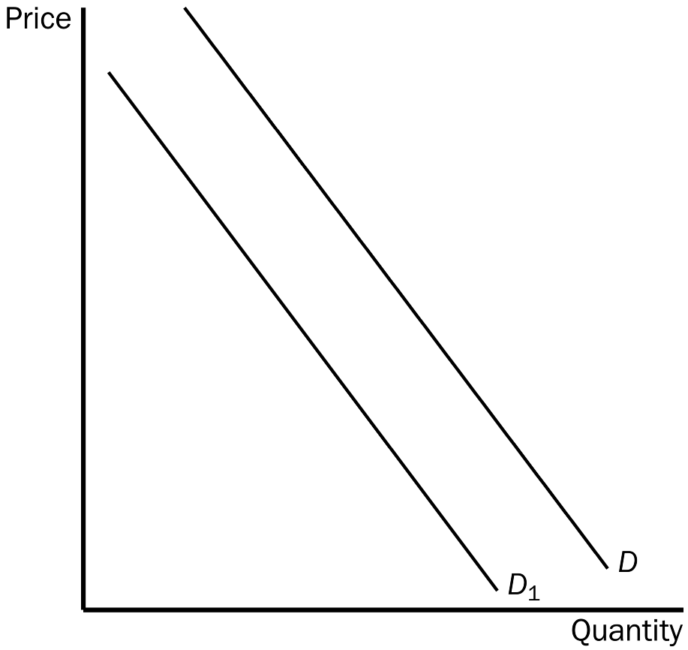
a. an increase in demand.
b. a decrease in demand.
c. a decrease in quantity demanded.
d. an increase in quantity demanded.
ANSWER: b. a decrease in demand.
TYPE: M SECTION: 2 DIFFICULTY: 2
108. On the graph, the movement from D to D1 could be caused by
a. an increase in price.
b. a decrease in the price of a complement.
c. an increase in technology.
d. a decrease in the price of a substitute.
ANSWER: d. a decrease in the price of a substitute.
TYPE: M SECTION: 2 DIFFICULTY: 3
109. According to the graph, if the demand curve shifts from D1 to D, then
a. firms would be willing to supply less than before.
b. people are less willing to buy the product at any price than before.
c. people are now more willing to buy the product at any price than before.
d. the price of the product has decreased, causing consumers to buy more of the product.
ANSWER: c. people are now more willing to buy the product at any price than before.
TYPE: M SECTION: 2 DIFFICULTY: 2
110. When quantity demanded decreases at every price we know that the demand curve has
a. shifted to the left.
b. shifted to the right.
c. not changed, but we have moved down the curve to a new point.
d. not changed, but we have moved up the curve to a new point.
ANSWER: a. shifted to the left.
TYPE: M SECTION: 2 DIFFICULTY: 2
111. When quantity demanded has increased at every price, it might be because
a. the number of buyers in the market has decreased.
b. income has increased and this good is an inferior good.
c. the consumer prefers another good more than this good.
d. the price of a substitute good has increased.
ANSWER: d. the price of a substitute good has increased.
TYPE: M SECTION: 2 DIFFICULTY: 3
112. Most studies indicate that tobacco and marijuana tend to be
a. substitute goods.
b. complementary goods.
c. not related since one is legal and one is illegal.
d. inferior goods.
ANSWER: b. complementary goods.
TYPE: M SECTION: 2 DIFFICULTY: 2
113. The graph shows the demand for cigarettes. According to the graph, which most likely happened?
a. The price of marijuana, a complement to cigarettes, rose.
b. Mandatory health warnings were placed on cigarette packages.
c. Several foreign countries banned U.S. cigarettes in their countries.
d. A tax was placed on cigarettes.
ANSWER: d. A tax was placed on cigarettes.
TYPE: M SECTION: 2 DIFFICULTY: 3

114. Which graph could be used to show the result of 5 percent of the country’s smokers deciding to stop smoking?
a. A
b. B
c. C
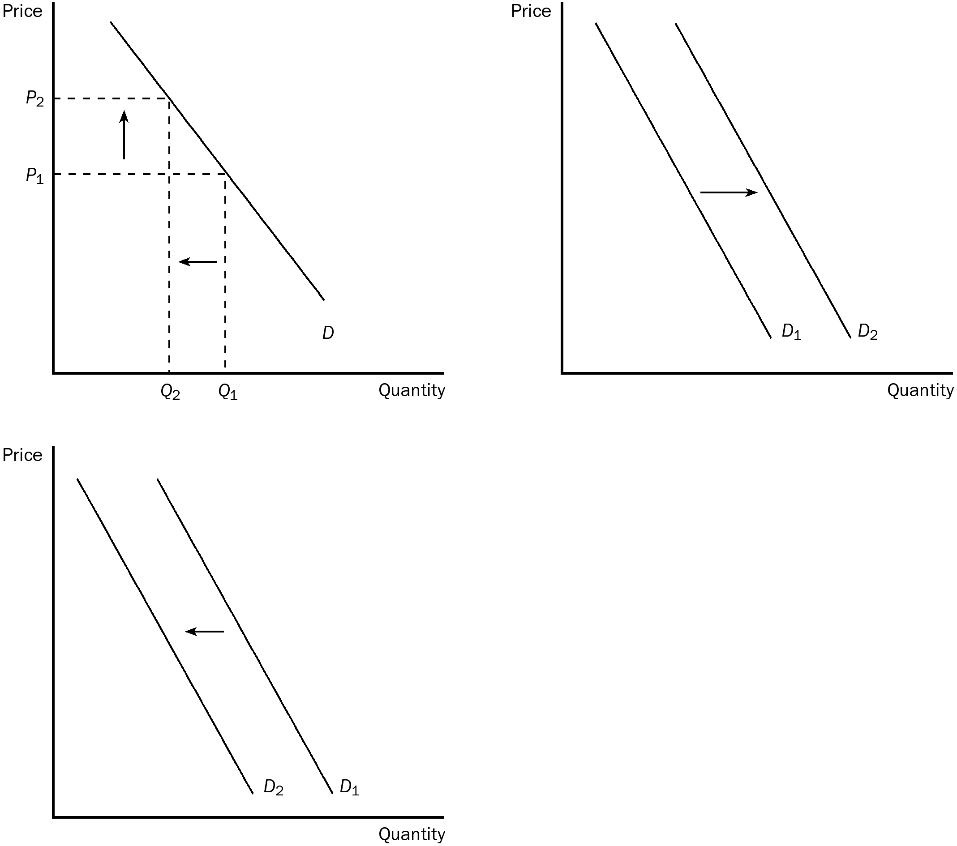
d. Each graph could be used to show the result.
ANSWER: c. C
TYPE: M SECTION: 2 DIFFICULTY: 3
115. If cigarettes and marijuana had been found to be substitutes, a tax placed on cigarettes would
a. decrease the demand for marijuana.
b. increase the demand for marijuana.
c. decrease the quantity demanded of marijuana.
d. increase the quantity demanded of marijuana.
ANSWER: b. increase the demand for marijuana.
TYPE: M SECTION: 2 DIFFICULTY: 3
116. One reason why government taxes on cigarettes reduce smoking is that
a. cigarette companies are successful in passing much of the tax on to consumers.
b. cigarette companies do not pass much of the tax on to consumers.
c. there are many good substitutes for cigarettes.
d. None of the above answers are correct.
ANSWER: a. cigarette companies are successful in passing much of the tax on to consumers.
TYPE: M SECTION: 2 DIFFICULTY: 2
117. For teens, a 10 percent increase in the price of cigarettes leads to a
a. 6 percent drop in teenage smoking.
b. 12 percent drop in teenage smoking.
c. 18 percent drop in teenage smoking.
d. 24 percent drop in teenage smoking.
ANSWER: b. 12 percent drop in teenage smoking.
TYPE: M SECTION: 2 DIFFICULTY: 2
118. The side of the market that deals with the willingness and ability to produce and sell is
a. demand.
b. competition.
c. supply.
d. a monopoly.
ANSWER: c. supply.
TYPE: M SECTION: 3 DIFFICULTY: 1
119. The relationship between price and quantity supplied is
a. negative, or inverse.
b. positive, or direct.
c. nonexistent.
d. the same as the relationship between price and quantity demanded.
ANSWER: b. positive, or direct.
TYPE: M SECTION: 3 DIFFICULTY: 1
120. Other things equal, when the price of a good rises, the
a. quantity demanded of the good increases.
b. supply increases.
c. quantity supplied of the good rises.
d. demand curve shifts to the left.
ANSWER: c. quantity supplied of the good rises.
TYPE: M SECTION: 3 DIFFICULTY: 2
121. If the price of a good is low
a. firms would increase profit by increasing output.
b. quantity supplied could be zero.
c. the supply curve for the good will shift to the left.
d. firms should raise the price of the product.
ANSWER: b. quantity supplied could be zero.
TYPE: M SECTION: 3 DIFFICULTY: 2
122. The supply schedule is a table that shows the relationship between
a. price and quantity supplied.
b. price and quantity demanded.
c. supply and quantity.
d. profit and price.
ANSWER: a. price and quantity supplied.
TYPE: M SECTION: 3 DIFFICULTY: 1
123. The difference between a supply schedule and a supply curve is that one
a. includes demand and one does not.
b. is verbal and one is mathematical.
c. is positively related and one is negatively related to price.
d. is a table and one is a graph.
ANSWER: d. is a table and one is a graph.
TYPE: M SECTION: 3 DIFFICULTY: 1
124. A market supply curve is determined by
a. vertically summing individual supply curves.
b. horizontally summing individual supply curves.
c. finding the average quantity supplied of the market’s individual supply curves.
d. Unlike market demand, there is no such thing as a market supply curve.
ANSWER: b. horizontally summing individual supply curves.
TYPE: M SECTION: 3 DIFFICULTY: 1
125. The market supply curve shows
a. the total quantity supplied at any price.
b. the average quantity supplied at any price.
c. a ratio between price and quantity supplied for the market.
d. a supply curve representing the 10 largest firms in the market.
ANSWER: a. the total quantity supplied at any price.
TYPE: M SECTION: 3 DIFFICULTY: 1
126. For a seller, which of the following is NOT positively related?
a. the price of the good and the seller’s profit
b. the price of the good and quantity supplied
c. the seller’s profit and product cost
d. the seller’s profit and quantity supplied
ANSWER: c. the seller’s profit and product cost
TYPE: M SECTION: 3 DIFFICULTY: 2
127. Which of the following cause and effect events is in order for a seller?
a. Technology improves, profit falls, the supply curve shifts left.
b. An input price falls, profit increases, the supply curve shifts right.
c. An input price rises, profit falls, the supply curve shifts right.
d. An input price rises, profit rises, the supply curve shifts left.
ANSWER: b. An input price falls, profit increases, the supply curve shifts right.
TYPE: M SECTION: 3 DIFFICULTY: 3
128. The positive relationship between price and quantity supplied is called
a. a market.
b. a change in supply.
c. the demand curve.
d. the law of supply.
ANSWER: d. the law of supply.
TYPE: M SECTION: 3 DIFFICULTY: 1
129. The supply of a good is negatively related to the
a. price of inputs used to make the good.
b. demand for the good by consumers.
c. price of the good itself.
d. amount of profit a firm can expect to receive from sale of the good.
ANSWER: a. price of inputs used to make the good.
TYPE: M SECTION: 3 DIFFICULTY: 2
130. Other things equal, when the price of a good rises, the quantity supplied of the good also rises. This is the law of
a. increasing costs.
b. diminishing returns.
c. supply.
d. demand.
ANSWER: c. supply.
TYPE: M SECTION: 3 DIFFICULTY: 1
131. If the number of sellers in a market increases, the
a. demand in that market will increase.
b. supply in that market will increase.
c. supply in that market will decrease.
d. demand in that market will decrease.
ANSWER: b. supply in that market will increase.
TYPE: M SECTION: 3 DIFFICULTY: 1
132. Fewer sellers in the market causes
a. the supply curve to shift to the left.
b. the supply curve to shift to the right.
c. a movement up a stationary supply curve.
d. a movement down a stationary supply curve.
ANSWER: a. the supply curve to shift to the left.
TYPE: M SECTION: 3 DIFFICULTY: 2
133. Which of the following determines a market supply curve but not an individual supply curve?
a. number of sellers
b. expectations
c. input prices
d. technology
ANSWER: a. number of sellers
TYPE: M SECTION: 3 DIFFICULTY: 2
134. A movement along the supply curve might be caused by a change in
a. technology.
b. input prices.
c. expectations about future prices.
d. the price of the good or service.
ANSWER: d. the price of the good or service.
TYPE: M SECTION: 3 DIFFICULTY: 2
135. Lead is an important input in the production of crystal. If the price of lead decreases, all else equal, we would expect the supply of
a. crystal to be unaffected.
b. crystal to decrease.
c. crystal to increase.
d. lead to increase.
ANSWER: c. crystal to increase.
TYPE: M SECTION: 3 DIFFICULTY: 3
136. Suppose you make jewelry. If the price of gold falls, we would expect you to
a. be willing and able to produce less jewelry than before at each possible price.
b. be willing and able to produce more jewelry than before at each possible price.
c. face a greater demand for your jewelry.
d. face a weaker demand for your jewelry.
ANSWER: b. be willing and able to produce more jewelry than before at each possible price.
TYPE: M SECTION: 3 DIFFICULTY: 2
137. A technological advancement will shift the
a. supply curve to the right.
b. demand curve to the left.
c. demand curve to the right.
d. supply curve to the left.
ANSWER: a. supply curve to the right.
TYPE: M SECTION: 3 DIFFICULTY: 2
138. An advance in production technology will
a. increase a firm’s costs.
b. allow firms to raise the price of their product.
c. shift the supply curve to the right.
d. Both a and b are correct.
ANSWER: c. shift the supply curve to the right.
TYPE: M SECTION: 3 DIFFICULTY: 2
139. A dress manufacturer is expecting higher prices for dresses in the near future. We would expect
a. the dress manufacturer to supply more dresses now.
b. the dress manufacturer to supply fewer dresses now.
c. the demand for this manufacturer’s dresses to fall.
d. no change in the dress manufacturer’s current supply.
ANSWER: b. the dress manufacturer to supply fewer dresses now.
TYPE: M SECTION: 3 DIFFICULTY: 2
140. Holding the nonprice determinants of supply constant, a change in price would
a. result in a change in supply.
b. have no effect on the quantity supplied.
c. result in a shift of demand.
d. result in a movement along a stable supply curve.
ANSWER: d. result in a movement along a stable supply curve.
TYPE: M SECTION: 3 DIFFICULTY: 2
141. A supply curve slopes upward because
a. as more is produced, total cost of production falls.
b. an increase in input prices increases supply.
c. a decrease in input prices decreases supply.
d. an increase in price gives producers incentive to supply a larger quantity.
ANSWER: d. an increase in price gives producers incentive to supply a larger quantity.
TYPE: M SECTION: 3 DIFFICULTY: 2
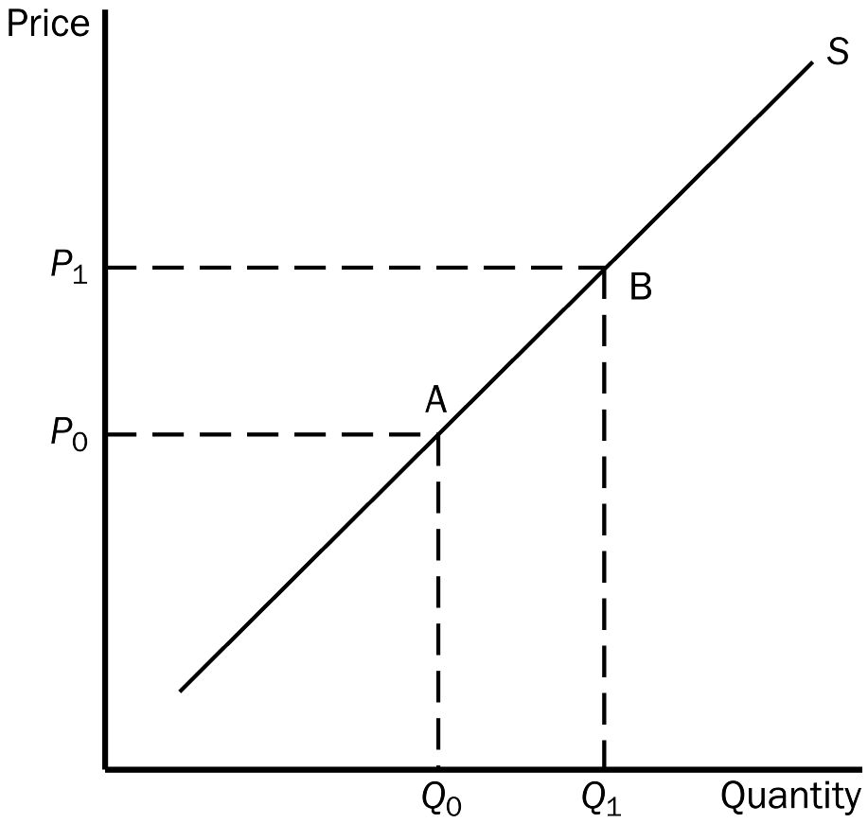
142. The movement from point A to point B on the graph would be caused by
a. a decrease in the price of the good.
b. an increase in the price of the good.
c. an increase in technology.
d. a decrease in input prices.
ANSWER: b. an increase in the price of the good.
TYPE: M SECTION: 3 DIFFICULTY: 2
143. The movement from point A to point B on the graph is called
a. a decrease in supply.
b. an increase in supply.
c. an increase in the quantity supplied.
d. a decrease in the quantity supplied.
ANSWER: c. an increase in the quantity supplied.
TYPE: M SECTION: 3 DIFFICULTY: 2
144. In a market, to find the total amount supplied at a particular price,
a. we must add up all of the amounts firms are willing and able to supply at that price.
b. we need to know the demand for the good as well.
c. the tastes and preferences of buyers must be established.
d. the income level of buyers would need to be determined.
ANSWER: a. we must add up all of the amounts firms are willing and able to supply at that price.
TYPE: M SECTION: 3 DIFFICULTY: 2
145. When evaluating differences or similarities between an increase in supply and an increase in quantity supplied we know that
a. the former is a shift of the curve and the latter is a movement along the curve.
b. the former is a movement along the curve and the latter is a shift of the curve.
c. both are shifts of the supply curve.
d. both are movements along the curve.
ANSWER: a. the former is a shift of the curve and the latter is a movement along the curve.
TYPE: M SECTION: 3 DIFFICULTY: 2
146. A leftward shift in supply is
a. an increase in supply.
b. a decrease in supply.
c. a decrease in quantity supplied.
d. an increase in quantity supplied.
ANSWER: b. a decrease in supply.
TYPE: M SECTION: 3 DIFFICULTY: 2
147. Workers at a bicycle assembly plant currently make minimum wage. If the federal government increases the minimum wage by $1.00 an hour it is likely that the
a. demand for bicycle assembly workers will increase.
b. supply of bicycles will shift to the right.
c. supply of bicycles will shift to the left.
d. firm must increase output to maintain profit levels.
ANSWER: c. supply of bicycles will shift to the left.
TYPE: M SECTION: 3 DIFFICULTY: 2
148. If a car manufacturer purchases new labor-saving technology for its assembly line, we would NOT expect
a. less labor to be used.
b. the supply of cars produced to increase.
c. costs to the firm to fall.
d. the price of cars to be increased by the firm.
ANSWER: d. the price of cars to be increased by the firm.
TYPE: M SECTION: 3 DIFFICULTY: 2
149. Recent forest fires in the western states are expected to cause the price of lumber to rise in the next 6 months. As a result we can expect the supply of lumber to
a. fall in 6 months, but not now.
b. increase in 6 months when the price goes up.
c. fall now.
d. increase now to meet as much demand as possible.
ANSWER: c. fall now.
TYPE: M SECTION: 3 DIFFICULTY: 3
150. If suppliers expect the price of their product to fall in the future they will
a. decrease supply now.
b. increase supply now.
c. increase supply in the future but not now.
d. do nothing, since there is nothing they can do to affect the price in the future.
ANSWER: b. increase supply now.
TYPE: M SECTION: 3 DIFFICULTY: 2
151. Funsters, Inc., the largest toy company in the country, sells its most popular doll for $15. It has just learned that its leading competitor Toysorama is mass producing an excellent copy and plans to flood the market with their $5 doll in 6 weeks. Funsters should
a. increase the supply of their doll now before the other doll hits the market.
b. fight fire with fire and decrease supply for 6 weeks and then increase the supply of its doll too.
c. continue business as usual, since consumers will not buy the cheaper imitation.
d. discontinue this doll.
ANSWER: a. increase the supply of their doll now before the other doll hits the market.
TYPE: M SECTION: 3 DIFFICULTY: 3
152. Suppose there is an increase in input prices. We would expect supply
a. to decrease.
b. to increase.
c. could increase or decrease.
d. to remain unchanged.
ANSWER: a. to decrease.
TYPE: M SECTION: 3 DIFFICULTY: 2
153. An increase in the price of a good would
a. increase the supply.
b. increase the amount purchased by buyers.
c. give producers an incentive to produce more.
d. decrease the supply.
ANSWER: c. give producers an incentive to produce more.
TYPE: M SECTION: 3 DIFFICULTY: 2
154. Wheat is the main input in the production of flour. If the price of wheat increases, all else equal, we would expect the
a. supply of flour to be unaffected.
b. supply of flour to decrease.
c. supply of flour to increase.
d. demand for flour to decrease.
ANSWER: b. supply of flour to decrease.
TYPE: M SECTION: 3 DIFFICULTY: 2
155. An increase in the price of oranges would lead to
a. an increased supply of oranges.
b. a reduction in the prices of inputs used in orange production.
c. an increased demand for oranges.
d. a movement up the supply curve for oranges.
ANSWER: d. a movement up the supply curve for oranges.
TYPE: M SECTION: 3 DIFFICULTY: 2
156. All else constant, an increase in the number of cattle delivered to an auction to be marketed would
a. represent an increase in the supply of cattle at the auction.
b. represent an increase in demand for cattle at the auction.
c. represent a decrease in the number of sellers at the auction.
d. have no effect on the demand or supply at the auction.
ANSWER: a. represent an increase in the supply of cattle at the auction.
TYPE: M SECTION: 3 DIFFICULTY: 2
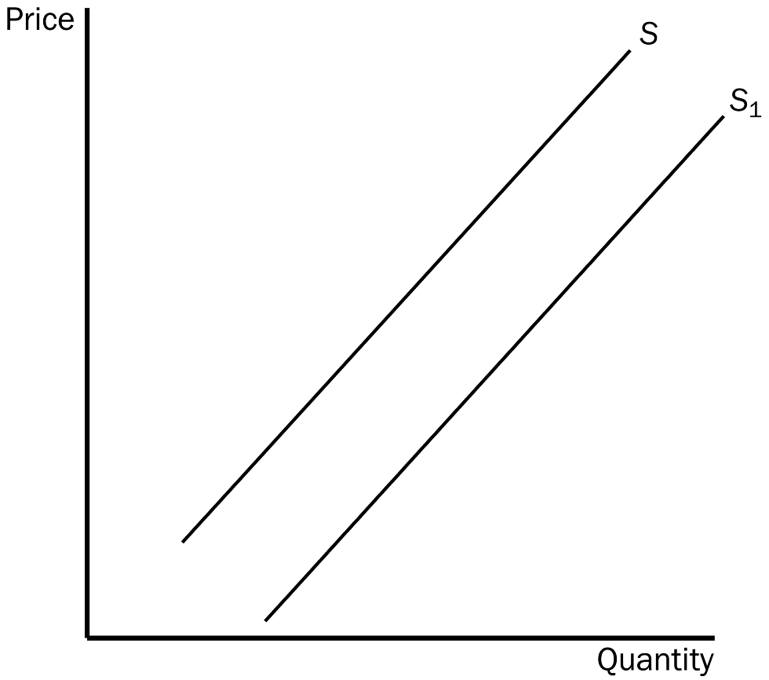
157. On the graph, the movement from S to S1 is called
a. a decrease in supply.
b. a decrease in quantity supplied.
c. an increase in supply.
d. an increase in quantity supplied.
ANSWER: c. an increase in supply.
TYPE: M SECTION: 3 DIFFICULTY: 2
158. On the graph, the movement from S to S1 could be caused by
a. a decrease in the price of the good.
b. an improvement in technology.
c. an increase in income.
d. an increase in input prices.
ANSWER: b. an improvement in technology.
TYPE: M SECTION: 3 DIFFICULTY: 2
159. The unique point at which the supply and demand curves intersect is called
a. market unity.
b. an agreement.
c. cohesion.
d. equilibrium.
ANSWER: d. equilibrium.
TYPE: M SECTION: 4 DIFFICULTY: 1
160. The dictionary defines equilibrium as a situation in which forces
a. balance.
b. are the same.
c. coincide.
d. remain constant.
ANSWER: a. balance.
TYPE: M SECTION: 4 DIFFICULTY: 1
161. The price where quantity supplied equals quantity demanded is called the
a. coordinating price.
b. monopoly price.
c. equilibrium price.
d. All of the above are correct.
ANSWER: c. equilibrium price.
TYPE: M SECTION: 4 DIFFICULTY: 1
162. Another term for equilibrium price is
a. balancing price.
b. market-clearing price.
c. constant price.
d. satisfactory price.
ANSWER: b. market-clearing price.
TYPE: M SECTION: 4 DIFFICULTY: 1
163. If, at the current price, there is a shortage of a good,
a. sellers are producing more than buyers wish to buy.
b. the market must be in equilibrium.
c. the price is below the equilibrium price.
d. quantity demanded equals quantity supplied.
ANSWER: c. the price is below the equilibrium price.
TYPE: M SECTION: 4 DIFFICULTY: 2
164. At the equilibrium price,
a. buyers have an incentive to buy more.
b. it is possible for there to be a shortage.
c. firms have an incentive to increase production.
d. everyone in the market has been satisfied.
ANSWER: d. everyone in the market has been satisfied.
TYPE: M SECTION: 4 DIFFICULTY: 2
165. A decrease in resource costs to firms in a market will result in
a. a decrease in equilibrium price and an increase in equilibrium quantity.
b. a decrease in equilibrium price and a decrease in equilibrium quantity.
c. an increase in equilibrium price and no change in equilibrium quantity.
d. an increase in equilibrium price and an increase in equilibrium quantity.
ANSWER: a. a decrease in equilibrium price and an increase in equilibrium quantity.
TYPE: M SECTION: 4 DIFFICULTY: 3
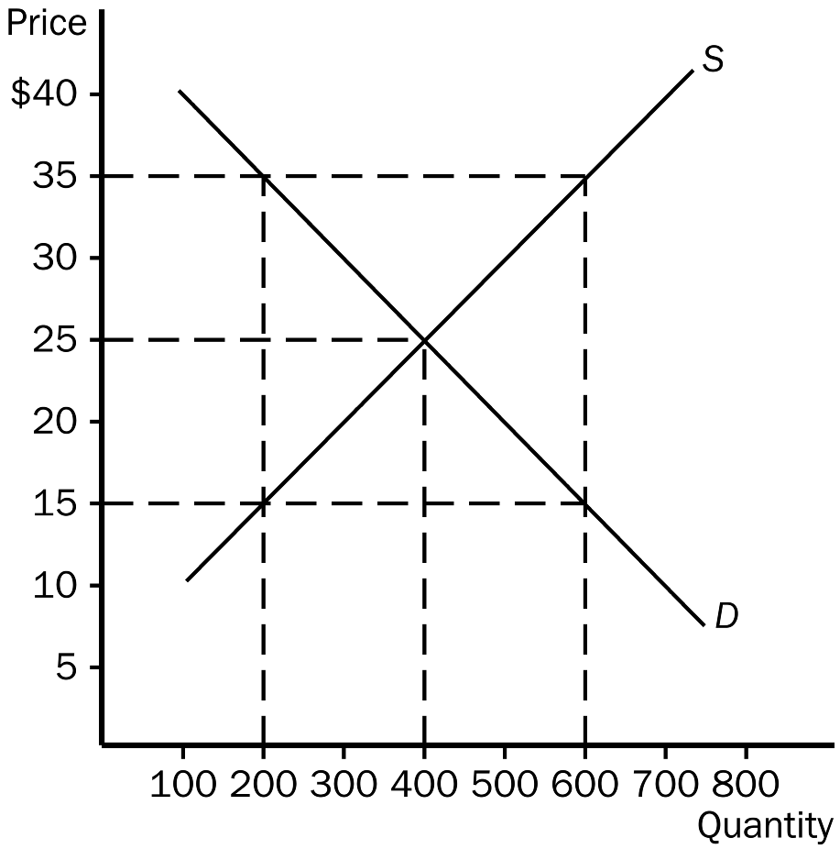
166. According to the graph, equilibrium price and quantity are
a. $35,200.
b. $35,600.
c. $25,400.
d. $15,200.
ANSWER: c. $25,400.
TYPE: M SECTION: 4 DIFFICULTY: 2
167. According to the graph, at a price of $35,
a. there would be a shortage of 400 units.
b. there would be a surplus of 200 units.
c. there would be a surplus of 400 units.
d. the market would be in equilibrium.
ANSWER: c. there would be a surplus of 400 units.
TYPE: M SECTION: 4 DIFFICULTY: 2
168. According to the graph, at a price of $15,
a. there would be a shortage of 400 units.
b. there would be a surplus of 400 units.
c. there would be a shortage of 200 units.
d. the market would be in equilibrium.
ANSWER: a. there would be a shortage of 400 units.
TYPE: M SECTION: 4 DIFFICULTY: 2
169. According to the graph, at the equilibrium price,
a. 200 units would be supplied and demanded.
b. 400 units would be supplied and demanded.
c. 600 units would be supplied and demanded.
d. 600 units would be supplied, but only 200 would be demanded.
ANSWER: b. 400 units would be supplied and demanded.
TYPE: M SECTION: 4 DIFFICULTY: 2
170. According to the graph, at a price of $35,
a. a shortage would exist and the price would tend to fall.
b. a surplus would exist and the price would tend to rise.
c. a surplus would exist and the price would tend to fall.
d. the market would be in equilibrium.
ANSWER: c. a surplus would exist and the price would tend to fall.
TYPE: M SECTION: 4 DIFFICULTY: 2

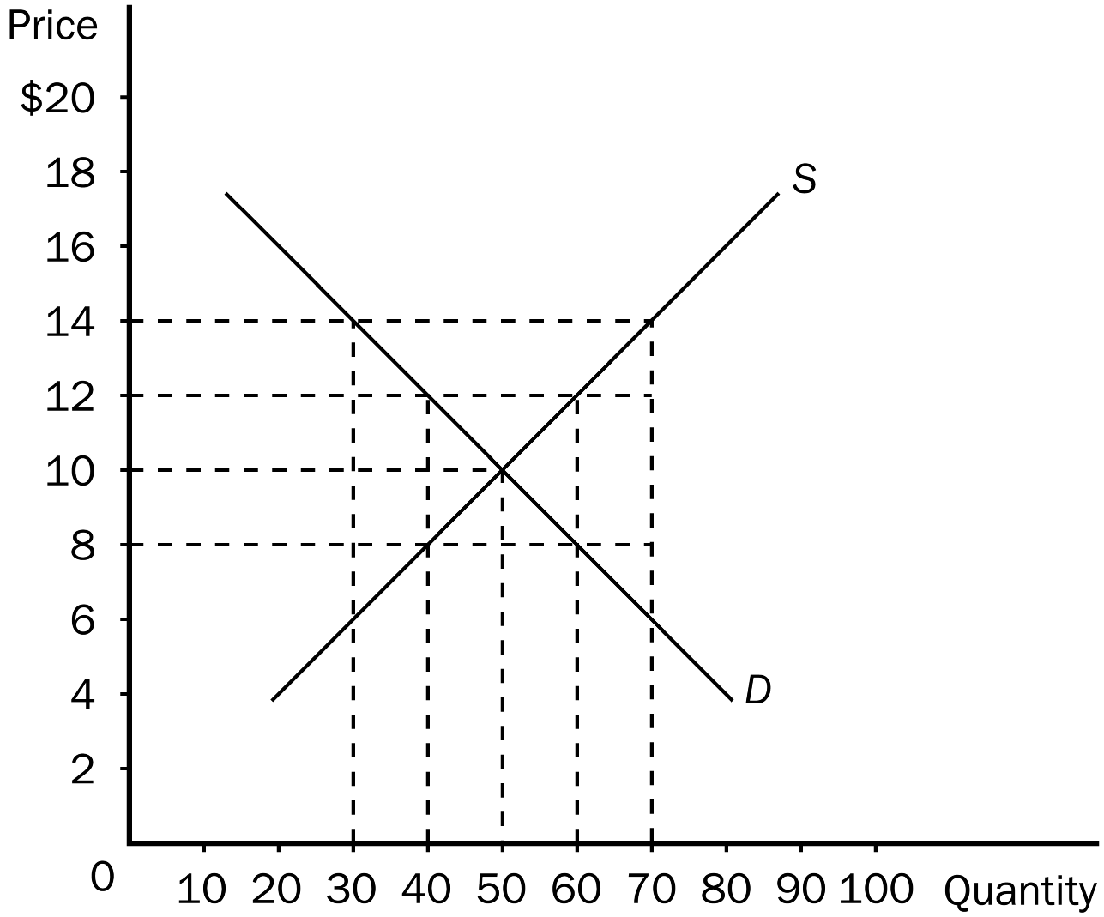
171. According to the graph shown, in this market, equilibrium price and quantity would be
a. $14.70.
b. $12.40.
c. $10.50.
d. $8.50.
ANSWER: c. $10.50.
TYPE: M SECTION: 4 DIFFICULTY: 2
172. According to the graph shown, if price in this market is currently $14, there would be a
a. shortage of 20 units and price would tend to rise.
b. surplus of 20 units and price would tend to fall.
c. shortage of 40 units and price would tend to rise.
d. surplus of 40 units and price would tend to fall.
ANSWER: d. surplus of 40 units and price would tend to fall.
TYPE: M SECTION: 4 DIFFICULTY: 3
173. According to the graph shown, if price in this market is currently $8, quantity supplied would be
a. 40 and quantity demanded would be 60.
b. 60 and quantity demanded would be 40.
c. 50 and quantity demanded would be 50.
d. 70 and quantity demanded would be 30.
ANSWER: a. 40 and quantity demanded would be 60.
TYPE: M SECTION: 4 DIFFICULTY: 3

PRICE | QUANTITY DEMANDED | QUANTITY SUPPLIED
$10 | 10 | 60
$8 | 20 | 45
$6 | 30 | 30
$4 | 40 | 15
$2 | 50 | 0

174. In the table shown, the equilibrium price and quantity would be
a. $4.40.
b. $6.30.
c. $8.30.
d. $10.35.
ANSWER: b. $6.30.
TYPE: M SECTION: 4 DIFFICULTY: 2
175. In the table shown, if the price were $8, a
a. surplus of 50 units would exist and price would tend to fall.
b. surplus of 10 units would exist and price would tend to fall.
c. surplus of 25 units would exist and price would tend to fall.
d. shortage of 25 units would exist and price would tend to rise.
ANSWER: c. surplus of 25 units would exist and price would tend to fall.
TYPE: M SECTION: 4 DIFFICULTY: 2
176. In the table shown, if the price were $2, a
a. shortage of 25 units would exist and price would tend to fall.
b. surplus of 50 units would exist and price would tend to rise.
c. surplus of 25 units would exist and price would tend to fall.
d. shortage of 50 units would exist and price would tend to rise.
ANSWER: d. shortage of 50 units would exist and price would tend to rise.
TYPE: M SECTION: 4 DIFFICULTY: 2

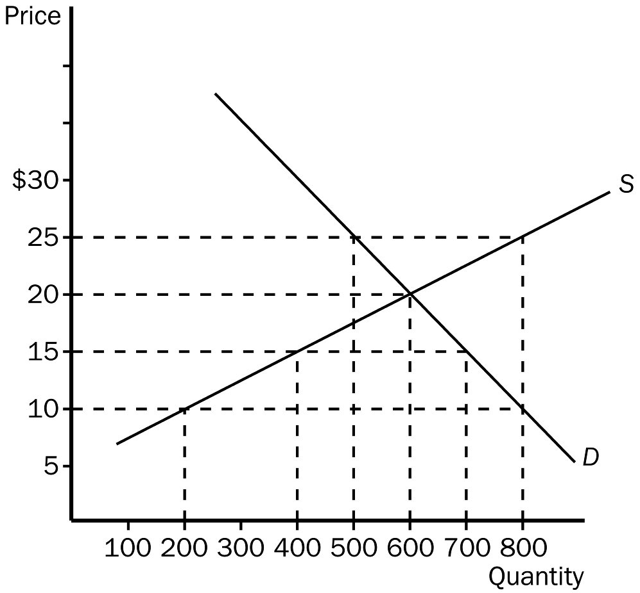
177. According to the graph shown, in this market, equilibrium price and quantity would be
a. $15,400.
b. $20,600.
c. $25,500.
d. $25,800.
ANSWER: b. $20,600.
TYPE: M SECTION: 4 DIFFICULTY: 2
178. According to the graph shown, if price is $25, quantity demanded would be
a. 400.
b. 500.
c. 600.
d. 800.
ANSWER: b. 500.
TYPE: M SECTION: 4 DIFFICULTY: 2
179. According to the graph shown, if price is $15, quantity supplied would be
a. 200.
b. 400.
c. 500.
d. 700.
ANSWER: b. 400.
TYPE: M SECTION: 4 DIFFICULTY: 2
180. According to the graph shown, if the price is $25, there would be a
a. surplus of 300 and price would fall.
b. surplus of 200 and price would fall.
c. shortage of 200 and price would rise.
d. shortage of 300 and price would rise.
ANSWER: a. surplus of 300 and price would fall.
TYPE: M SECTION: 4 DIFFICULTY: 3
181. According to the graph shown, if the price is $10, there would be a
a. shortage of 200 and price would rise.
b. surplus of 200 and price would fall.
c. shortage of 600 and price would rise.
d. surplus of 600 and price would fall.
ANSWER: c. shortage of 600 and price would rise.
TYPE: M SECTION: 4 DIFFICULTY: 3
182. According to the graph shown, at a price of $15
a. quantity demanded > quantity supplied.
b. quantity demanded = quantity supplied.
c. quantity demanded < quantity supplied.
d. None of the above are correct.
ANSWER: a. quantity demanded > quantity supplied.
TYPE: M SECTION: 4 DIFFICULTY: 2
183. According to the graph shown, at a price of $20, which would NOT be true?
a. The market would be in equilibrium.
b. Equilibrium price would be equal to equilibrium quantity.
c. There would be no pressure for price to change.
d. 600 units would be bought and sold.
ANSWER: b. Equilibrium price would be equal to equilibrium quantity.
TYPE: M SECTION: 4 DIFFICULTY: 2
184. Markets move toward equilibrium of supply and demand because of
a. the actions of buyers and sellers.
b. government regulations placed on market participants.
c. increased competition among sellers.
d. buyers’ ability to affect market decisions.
ANSWER: a. the actions of buyers and sellers.
TYPE: M SECTION: 4 DIFFICULTY: 2
185. When the price is higher than the equilibrium price,
a. a shortage will exist.
b. buyers desire to purchase more than is produced.
c. sellers desire to produce and sell more than buyers wish to purchase.
d. quantity demanded equals quantity supplied.
ANSWER: c. sellers desire to produce and sell more than buyers wish to purchase.
TYPE: M SECTION: 4 DIFFICULTY: 2
186. Suppose roses are currently selling for $40.00 per dozen. The equilibrium price of roses is $30.00 per dozen. We would expect a
a. shortage to exist and the market price of roses to increase.
b. shortage to exist and the market price of roses to decrease.
c. surplus to exist and the market price of roses to increase.
d. surplus to exist and the market price of roses to decrease.
ANSWER: d. surplus to exist and the market price of roses to decrease.
TYPE: M SECTION: 4 DIFFICULTY: 3
187. When there is a surplus in a market,
a. there is upward pressure on price.
b. there is downward pressure on price.
c. the market could still be in equilibrium.
d. there are too many buyers chasing too few goods.
ANSWER: b. there is downward pressure on price.
TYPE: M SECTION: 4 DIFFICULTY: 2
188. A surplus exists in a market if the actual price is
a. equal to equilibrium price.
b. below equilibrium price.
c. above equilibrium price.
d. All of the above are correct.
ANSWER: c. above equilibrium price.
TYPE: M SECTION: 4 DIFFICULTY: 2
189. If a surplus exists in a market we know that the actual price is
a. above equilibrium price and quantity supplied is greater than quantity demanded.
b. above equilibrium price and quantity demanded is greater than quantity supplied.
c. below equilibrium price and quantity demanded is greater than quantity supplied.
d. below equilibrium price and quantity supplied is greater than quantity demanded.
ANSWER: a. above equilibrium price and quantity supplied is greater than quantity demanded.
TYPE: M SECTION: 4 DIFFICULTY: 3
190. When there is a shortage in a market,
a. there is downward pressure on price.
b. there is upward pressure on price.
c. the market could still be in equilibrium.
d. the price must be above equilibrium.
ANSWER: b. there is upward pressure on price.
TYPE: M SECTION: 4 DIFFICULTY: 2
191. If a shortage exists in a market we know that the actual price is
a. below equilibrium price and quantity demanded is greater than quantity supplied.
b. above equilibrium price and quantity demanded is greater than quantity supplied.
c. above equilibrium price and quantity supplied is greater than quantity demanded.
d. below equilibrium price and quantity supplied is greater than quantity demanded.
ANSWER: a. below equilibrium price and quantity demanded is greater than quantity supplied.
TYPE: M SECTION: 4 DIFFICULTY: 3
192. At the equilibrium price
a. there can still be upward or downward pressure on price.
b. there will be no pressure on price to rise or fall.
c. sellers would eventually require a higher price.
d. buyers would not be willing to purchase the output sellers desire to sell.
ANSWER: b. there will be no pressure on price to rise or fall.
TYPE: M SECTION: 4 DIFFICULTY: 2
193. Comparative statics involves
a. comparisons of varying prices.
b. evaluation of buyers’ reluctance to pay the market price.
c. comparing the old equilibrium and the new equilibrium.
d. evaluating the friction that develops between buyers and sellers.
ANSWER: c. comparing the old equilibrium and the new equilibrium.
TYPE: M SECTION: 4 DIFFICULTY: 2
194. Step one in the Three-Step program for analyzing changes in equilibrium is
a. Decide which direction the curve shifts.
b. Decide whether the event shifts the supply or demand curve.
c. Use the supply-and-demand diagram to see how the shift changes the equilibrium.
d. Any of these could be used first.
ANSWER: b. Decide whether the event shifts the supply or demand curve.
TYPE: M SECTION: 4 DIFFICULTY: 1
195. You have been asked by your economics professor to graph the market for lumber and then to analyze the change that would occur in equilibrium price as a result of recent forest fires in the west. Your first step would be to
a. decide which direction to shift the curve.
b. decide whether the fires affected demand or supply.
c. graph the shift to see the affect on equilibrium.
d. None of the above are correct.
ANSWER: d. decide whether the fires affected demand or supply.
TYPE: M SECTION: 4 DIFFICULTY: 2

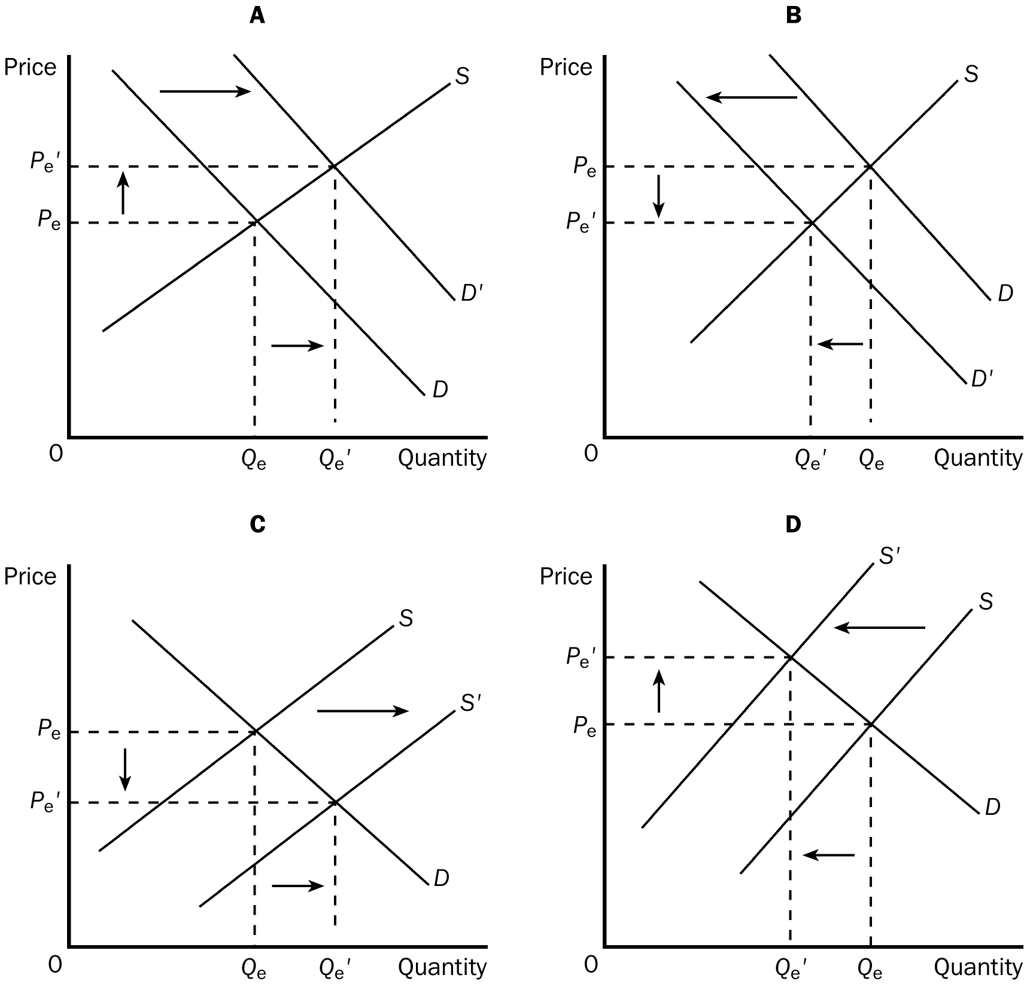
196. Which of the four graphs represents the market for peanut butter after a major hurricane hits the peanut-growing south?
a. A
b. B
c. C
d. D
ANSWER: d. D
TYPE: M SECTION: 4 DIFFICULTY: 2
197. Which of the four graphs represents the market for winter boots in June?
a. A
b. B
c. C
d. D
ANSWER: b. B.
TYPE: M SECTION: 4 DIFFICULTY: 2
198. Which of the four graphs represents the market for pizza delivery in a college town in September?
a. A
b. B
c. C
d. D
ANSWER: a. A.
TYPE: M SECTION: 4 DIFFICULTY: 2
199. Which of the four graphs represents the market for cars after new technology was installed on assembly lines?
a. A
b. B
c. C
d. D
ANSWER: c. C.
TYPE: M SECTION: 4 DIFFICULTY: 2
200. Graph A shows which of the following?
a. an increase in demand
b. an increase in quantity demanded
c. an increase in quantity supplied
d. All of the above are correct.
e. Both a and c are correct.
ANSWER: e. Both a and c are correct.
TYPE: M SECTION: 4 DIFFICULTY: 3
201. Graph C shows which of the following?
a. an increase in demand
b. an increase in quantity demanded
c. an increase in supply
d. All of the above are correct.
e. Both b and c are correct.
ANSWER: e. Both b and c are correct.
TYPE: M SECTION: 4 DIFFICULTY: 3
202. Which of the four graphs shown illustrates an increase in quantity supplied?
a. A.
b. B.
c. C.
d. D.
ANSWER: a. A.
TYPE: M SECTION: 4 DIFFICULTY: 3
203. Which of the four graphs shown illustrates a decrease in quantity demanded?
a. A.
b. B.
c. C.
d. D.
ANSWER: d. D.
TYPE: M SECTION: 4 DIFFICULTY: 3
204. Which of the following is NOT one of the steps in analyzing how some event affects a market?
a. Determine the number of market participants.
b. Decide whether the curve shifts to the right or to the left.
c. Determine whether the event shifts the supply, the demand, or both curves.
d. Use a supply-demand diagram to examine how the shift(s) affect the equilibrium.
ANSWER: a. Determine the number of market participants.
TYPE: M SECTION: 4 DIFFICULTY: 2
205. Which chain of events occurs in the correct order?
a. Quantity supplied increases, price increases, demand increases.
b. Price increases, demand increases, quantity supplied increases.
c. Demand increases, price increases, quantity supplied increases.
d. Any of the above could be correct.
ANSWER: c. Demand increases, price increases, quantity supplied increases.
TYPE: M SECTION: 4 DIFFICULTY: 3
206. Whenever the price of a good changes, there
a. is a change in supply and demand.
b. would be a movement along a supply curve and/or demand curve.
c. is only a change in supply.
d. would be no effect in the market.
ANSWER: b. would be a movement along a supply curve and/or demand curve.
TYPE: M SECTION: 4 DIFFICULTY: 2
207. Suppose there is an earthquake that destroys several corn canneries. Which of the following would NOT occur as a direct result of this event?
a. Sellers would not be willing to produce and sell as much as before at each relevant price.
b. The supply would decrease.
c. Buyers would not be willing to buy as much as before at each relevant price.
d. The equilibrium price would rise.
ANSWER: c. Buyers would not be willing to buy as much as before at each relevant price.
TYPE: M SECTION: 4 DIFFICULTY: 2
208. An early frost in the vineyards of Napa Valley would cause
a. an increase in the demand for wine, increasing price.
b. an increase in the supply of wine, decreasing price.
c. a decrease in the demand for wine, decreasing price.
d. a decrease in the supply of wine, increasing price.
ANSWER: d. a decrease in the supply of wine, increasing price.
TYPE: M SECTION: 4 DIFFICULTY: 3
209. Which of the following would definitely result in a higher price in the market for Snickers?
a. demand increases and supply decreases
b. demand and supply both decrease
c. demand decreases and supply increases
d. demand and supply both increase
ANSWER: a. demand increases and supply decreases
TYPE: M SECTION: 4 DIFFICULTY: 3
210. Which of the following will definitely cause equilibrium quantity to fall?
a. demand increases and supply decreases
b. demand and supply both decrease
c. demand decreases and supply increases
d. demand and supply both increase
ANSWER: b. demand and supply both decrease
TYPE: M SECTION: 4 DIFFICULTY: 3
211. If the demand for a product increases, we would expect equilibrium price
a. to increase and equilibrium quantity to decrease.
b. to decrease and equilibrium quantity to increase.
c. and equilibrium quantity to both increase.
d. and equilibrium quantity to both decrease.
ANSWER: c. and equilibrium quantity to both increase.
TYPE: M SECTION: 4 DIFFICULTY: 2
212. If the demand for a product decreases, we would expect equilibrium price
a. to increase and equilibrium quantity to decrease.
b. to decrease and equilibrium quantity to increase.
c. and equilibrium quantity to both increase.
d. and equilibrium quantity to both decrease.
ANSWER: d. and equilibrium quantity to both decrease.
TYPE: M SECTION: 4 DIFFICULTY:2
213. If the supply of a product increases, we would expect equilibrium price
a. to increase and equilibrium quantity to decrease.
b. to decrease and equilibrium quantity to increase.
c. and equilibrium quantity to both increase.
d. and equilibrium quantity to both decrease.
ANSWER: b. to decrease and equilibrium quantity to increase.
TYPE: M SECTION: 4 DIFFICULTY: 2
214. If the supply of a product decreases, we would expect equilibrium price
a. to increase and equilibrium quantity to decrease.
b. to decrease and equilibrium quantity to increase.
c. and equilibrium quantity to both increase.
d. and equilibrium quantity to both decrease.
ANSWER: a. to increase and equilibrium quantity to decrease.
TYPE: M SECTION: 4 DIFFICULTY: 2
215. Suppose that the number of buyers in a market increases and a technological advancement occurs also. What would we expect to happen in the market?
a. The equilibrium price would increase, but the impact on the amount sold in the market would be ambiguous.
b. The equilibrium price would decrease, but the impact on the amount sold in the market would be ambiguous.
c. Equilibrium quantity would increase, but the impact on equilibrium price would be ambiguous.
d. Both equilibrium price and equilibrium quantity would increase.
ANSWER: c. Equilibrium quantity would increase, but the impact on equilibrium price would be ambiguous.
TYPE: M SECTION: 4 DIFFICULTY: 3
216. Suppose that the incomes of buyers in a particular market for a normal good decline and there is also a reduction in input prices. What would we expect to occur in this market?
a. The equilibrium price would increase, but the impact on the amount sold in the market would be ambiguous.
b. The equilibrium price would decrease, but the impact on the amount sold in the market would be ambiguous.
c. Both equilibrium price and equilibrium quantity would increase.
d. Equilibrium quantity would increase, but the impact on equilibrium price would be ambiguous.
ANSWER: b. The equilibrium price would decrease, but the impact on the amount sold in the market would be ambiguous.
TYPE: M SECTION: 4 DIFFICULTY: 3
217. Suppose that demand decreases AND supply decreases. What would you expect to occur in the market for the good?
a. Equilibrium price would increase, but the impact on equilibrium quantity would be ambiguous.
b. Equilibrium price would decrease, but the impact on equilibrium quantity would be ambiguous.
c. Equilibrium quantity would decrease, but the impact on equilibrium price would be ambiguous.
d. Both equilibrium price and equilibrium quantity would increase.
ANSWER: c. Equilibrium quantity would decrease, but the impact on equilibrium price would be ambiguous.
TYPE: M SECTION: 4 DIFFICULTY: 3
218. Suppose that demand increases AND supply decreases. What would happen in the market for the good?
a. Equilibrium price would decrease, but the impact on equilibrium quantity would be ambiguous.
b. Equilibrium price would increase, but the impact on equilibrium quantity would be ambiguous.
c. Both equilibrium price and quantity would increase.
d. Both equilibrium price and quantity would decrease.
ANSWER: b. Equilibrium price would increase, but the impact on equilibrium quantity would be ambiguous.
TYPE: M SECTION: 4 DIFFICULTY: 3
219. Which of the following would result in an increase in equilibrium price and an ambiguous change in equilibrium quantity?
a. an increase in supply and demand
b. an increase in supply and a decrease in demand
c. a decrease in supply and an increase in demand
d. a decrease in supply and demand
ANSWER: c. a decrease in supply and an increase in demand
TYPE: M SECTION: 4 DIFFICULTY: 3
220. When supply and demand both increase, equilibrium
a. price will increase.
b. price will decrease.
c. quantity may increase, decrease, or remain unchanged.
d. price may increase, decrease, or remain unchanged.
ANSWER: d. price may increase, decrease, or remain unchanged.
TYPE: M SECTION: 4 DIFFICULTY: 3
221. A weaker demand together with a stronger supply would necessarily result in
a. a lower price.
b. a higher price.
c. an increase in equilibrium quantity.
d. a decrease in equilibrium quantity.
ANSWER: a. a lower price.
TYPE: M SECTION: 4 DIFFICULTY: 3
222. The signals that guide the allocation of resources in a market economy are
a. laws.
b. buyers and sellers.
c. property rights.
d. prices.
ANSWER: d. prices.
TYPE: M SECTION: 5 DIFFICULTY: 1
223. In a free market system, what coordinates the actions of millions of people with their varying abilities and desires?
a. producers
b. prices
c. consumers
d. the government
ANSWER: b. prices
TYPE: M SECTION: 5 DIFFICULTY: 2
224. If there is a shortage of farm laborers, we would expect
a. the wages of farm laborers to increase.
b. the wages of farm laborers to decrease.
c. the prices of farm commodities to decrease.
d. a decrease in the demand for substitutes for farm labor.
ANSWER: a. the wages of farm laborers to increase.
TYPE: M SECTION: 5 DIFFICULTY: 2
225. For market economies, which would NOT be correct?
a. Prices guide economic decisions and thereby allocate scarce resources.
b. Prices ensure that quantity supplied and quantity demanded are in balance.
c. Prices ensure that anyone who wants a product can get it.
d. Prices influence how much of a good buyers choose to purchase and how much sellers choose to produce.
ANSWER: c. Prices ensure that anyone who wants a product can get it.
TYPE: M SECTION: 5 DIFFICULTY: 2

 | An Increase in Supply | A Decrease in Supply
An Increase in Demand | A | B
A Decrease in Demand | C | D
226. According to the table, the space that would represent an increase in equilibrium quantity and an indeterminate change in equilibrium price would be
a. A.
b. b.
c. C.
d. D.
ANSWER: a. A.
TYPE: M SECTION: 5 DIFFICULTY: 3
227. According to the table, the space that would represent an increase in equilibrium price and an indeterminate change in equilibrium quantity would be
a. A.
b. B.
c. C.
d. D.
ANSWER: b. B.
TYPE: M SECTION: 5 DIFFICULTY: 3
228. According to the table, the space that would represent a decrease in equilibrium price and an indeterminate change in equilibrium quantity would be
a. A.
b. B.
c. C.
d. D.
ANSWER: c. C.
TYPE: M SECTION: 5 DIFFICULTY: 3
229. According to the table, the space that would represent a decrease in equilibrium quantity and an indeterminate change in equilibrium price would be
a. A.
b. B.
c. C.
d. D.
ANSWER: d. D.
TYPE: M SECTION: 5 DIFFICULTY: 3
230. Which of the following would cause both the equilibrium price and equilibrium quantity of number two grade potatoes (an inferior good) to increase?
a. an increase in consumer income
b. a decrease in consumer income
c. greater government restrictions on agricultural chemicals
d. fewer government restrictions on agricultural chemicals
ANSWER: b. a decrease in consumer income
TYPE: M SECTION: 5 DIFFICULTY: 3
231. Which of the following would unambiguously cause a decrease in the equilibrium price of cotton shirts?
a. an increase in the price of wool shirts and a decrease in the price of raw cotton
b. a decrease in the price of wool shirts and a decrease in the price of raw cotton
c. an increase in the price of wool shirts and an increase in the price of raw cotton
d. a decrease in the price of wool shirts and an increase in the price of raw cotton
ANSWER: b. a decrease in the price of wool shirts and a decrease in the price of raw cotton
TYPE: M SECTION: 4 DIFFICULTY: 3
232. What would happen to the equilibrium price and quantity of coffee if the wages of coffee-bean pickers fell and the price of tea fell?
a. Price will fall and the effect on quantity is ambiguous.
b. Price will rise and the effect on quantity is ambiguous.
c. Quantity will fall and the effect on price is ambiguous.
d. Quantity will rise and the effect on price is ambiguous.
ANSWER: a. Price will fall and the effect on quantity is ambiguous.
TYPE: M SECTION: 4 DIFFICULTY: 3
233. New oak tables are normal goods. What would happen to the equilibrium price and quantity in the market for oak tables if the price of maple tables rises, the price of oak wood rises, more buyers enter the market for oak tables and the price of wood saws increased?
a. Price will fall and the effect on quantity is ambiguous.
b. Price will rise and the effect on quantity is ambiguous.
c. Quantity will fall and the effect on price is ambiguous.
d. Quantity will rise and the effect on price is ambiguous.
ANSWER: b. Price will rise and the effect on quantity is ambiguous.
TYPE: M SECTION: 4 DIFFICULTY: 3
234. What will happen to the equilibrium price and quantity of new cars if the price of gasoline rises, the price of steel rises, public transportation becomes cheaper and more comfortable, and auto-workers negotiate higher wages?
a. Price will fall and the effect on quantity is ambiguous.
b. Price will rise and the effect on quantity is ambiguous.
c. Quantity will fall and the effect on price is ambiguous.
d. Quantity will rise and the effect on price is ambiguous.
ANSWER: c. Quantity will fall and the effect on price is ambiguous.
TYPE: M SECTION: 4 DIFFICULTY: 3
235. Music compact discs are normal goods. What will happen to the equilibrium price and quantity of music compact discs if musicians accept lower royalties, compact disc players become cheaper, more firms start producing music compact discs and music lovers experience an increase in income?
a. Price will fall and the effect on quantity is ambiguous.
b. Price will rise and the effect on quantity is ambiguous.
c. Quantity will fall and the effect on price is ambiguous.
d. Quantity will rise and the effect on price is ambiguous.
ANSWER: d. Quantity will rise and the effect on price is ambiguous.
TYPE: M SECTION: 4 DIFFICULTY: 3
236. New cars are normal goods. What will happen to the equilibrium price of new cars if the price of gasoline rises, the price of steel falls, public transportation becomes cheaper and more comfortable, auto-workers accept lower wages and automobile insurance becomes more expensive?
a. Price will rise.
b. Price will fall.
c. Price will stay exactly the same.
d. The price change will be ambiguous.
ANSWER: b. Price will fall.
TYPE: M SECTION: 4 DIFFICULTY: 3
237. What will happen to the equilibrium price of new textbooks if more students attend college, paper becomes cheaper, textbook authors accept lower royalties and fewer used textbooks are sold?
a. Price will rise.
b. Price will fall.
c. Price will stay exactly the same.
d. The price change will be ambiguous.
ANSWER: d. The price change will be ambiguous.
TYPE: M SECTION: 4 DIFFICULTY: 3
238. Consider the market for new DVDs. If DVD players became cheaper, buyers expected DVD prices to fall next year, used DVDs became more expensive, and DVD production technology improved, then we could safely conclude that the equilibrium price of a new DVD would
a. rise.
b. fall.
c. stay the same.
d. We couldn’t be sure what it might do.
ANSWER: d. We couldn’t be sure what it might do.
TYPE: M SECTION: 4 DIFFICULTY: 3
239. What would happen to the equilibrium price and quantity of peanut butter if the price of peanuts went up, the price of jelly (a complementary good) fell, fewer firms decided to produce peanut butter, and health officials announced that eating peanut butter was good for you?
a. Price will fall and the effect on quantity is ambiguous.
b. Price will rise and the effect on quantity is ambiguous.
c. Quantity will fall and the effect on price is ambiguous.
d. The effect on both price and quantity is ambiguous.
ANSWER: b. Price will rise and the effect on quantity is ambiguous.
TYPE: M SECTION: 4 DIFFICULTY: 3
240. Pens are normal goods. What will happen to the equilibrium price of pens if the price of pencils rises, consumers experience an increase in income, writing in ink becomes fashionable, people expect the price of pens to rise in the near future, the population increases, fewer firms manufacture pens, and the wages of pen-makers increase?
a. Price will rise.
b. Price will fall.
c. Price will stay exactly the same.
d. The price change will be ambiguous.
ANSWER: a. Price will rise.
TYPE: M SECTION: 4 DIFFICULTY: 3
241. Pens are normal goods. What will happen to the equilibrium price of pens if the price of pencils falls, consumers experience an increase in income, writing in ink becomes fashionable, people expect the price of pens to fall in the near future, the population increases, fewer firms manufacture pens, and the wages of pen-makers decrease?
a. Price will rise.
b. Price will fall.
c. Price will stay exactly the same.
d. The price change will be ambiguous.
ANSWER: d. The price change will be ambiguous.
TYPE: M SECTION: 4 DIFFICULTY: 3
242. Beef is a normal good. You observe that both the equilibrium price and quantity of beef has fallen over time. Which of the following would be most consistent with this observation?
a. Consumers have experienced an increase in income and beef-production technology has improved.
b. The price of chicken has risen and the price of steak sauce has fallen.
c. Consumer tastes have changed so as to prefer beef less than before.
d. The demand curve for beef must be positively sloped.
ANSWER: c. Consumer tastes have changed so as to prefer beef less than before.
TYPE: M SECTION: 4 DIFFICULTY: 3
243. Which of the following would be most likely to increase the price of a new house?
a. Higher wages for carpenters, higher wood prices, increases in consumer incomes, higher apartment rents, increases in population and expectations of higher house prices in the future.
b. Lower wages for carpenters, lower wood prices, increases in consumer incomes, higher apartment rents, increases in population and expectations of higher house prices in the future.
c. Lower wages for carpenters, higher wood prices, decreases in consumer incomes, higher apartment rents, decreases in population and expectations of higher house prices in the future.
d. Lower wages for carpenters, lower wood prices, decreases in consumer incomes, lower apartment rents, decreases in population and expectations of lower house prices in the future.
ANSWER: a. Higher wages for carpenters, higher wood prices, increases in consumer incomes, higher apartment rents, increases in population and expectations of higher house prices in the future.
TYPE: M SECTION: 4 DIFFICULTY: 3
244. What will happen to the equilibrium price and quantity of traditional camera film if traditional cameras become more expensive, digital cameras become cheaper, the cost of the resources needed to manufacture traditional film falls and more firms decide to manufacture traditional film?
a. Price will fall and the effect on quantity is ambiguous.
b. Price will rise and the effect on quantity is ambiguous.
c. Quantity will fall and the effect on price is ambiguous.
d. The effect on both price and quantity is ambiguous.
ANSWER: a. Price will fall and the effect on quantity is ambiguous.
TYPE: M SECTION: 4 DIFFICULTY: 3
245. During the last few decades in the United States, health officials have argued that eating too much beef might be harmful to human health. As a result, there has been a significant decrease in the amount of beef produced. Which of the following best explains the decrease in production?
a. Beef producers, concerned about the health of their customers, decided to produce relatively less beef.
b. Government officials, concerned about consumer health, ordered beef producers to produce relatively less beef.
c. Individual consumers, concerned about their own health, decreased their demand for beef, which lowered the relative price of beef, making it less attractive to produce.
d. Anti-beef protesters have made it difficult for both buyers and sellers of beef to meet in the marketplace.
ANSWER: c. Individual consumers, concerned about their own health, decreased their demand for beef, which lowered the relative price of beef, making it less attractive to produce.
TYPE: M SECTION: 4 DIFFICULTY: 3
TRUE/FALSE
1. Price, which is determined by all buyers and sellers as they interact in the marketplace, allocates the economy’s scarce resources.
ANSWER: T TYPE: T
2. A market is a group of buyers and sellers of a particular product.
ANSWER: T TYPE: T SECTION: 1
3. In a perfectly competitive market, buyers and sellers are price setters.
ANSWER: F TYPE: T SECTION: 1
4. If a good or service has only one seller, it is called an oligopoly.
ANSWER: F TYPE: T SECTION: 1
5. The computer software industry is an example of monopolistic competition.
ANSWER: T TYPE: T SECTION: 1
6. A local cable TV company might be a monopolist.
ANSWER: T TYPE: T SECTION: 1
7. The quantity demanded of a product is the amount that buyers are willing and able to purchase at a particular price.
ANSWER: T TYPE: T SECTION: 2
8. The law of demand states that the quantity demanded of a product is positively related to price.
ANSWER: F TYPE: T SECTION: 2
9. If the demand for a good falls when income falls, the good is called an inferior good.
ANSWER: F TYPE: T SECTION: 2
10. When an increase in the price of one good lowers the demand for another good, the two goods are called complements.
ANSWER: T TYPE: T SECTION: 2
11. Baseballs and baseball bats are substitute goods.
ANSWER: F TYPE: T SECTION: 2
12. An increase in the price of pizza will shift the demand curve for pizza to the left.
ANSWER: F TYPE: T SECTION: 2
13. The market demand is the average of all of the individual demands for a particular good or service.
ANSWER: F TYPE: T SECTION: 2
14. Whenever a determinant of demand other than price changes, the demand curve shifts.
ANSWER: T TYPE: T SECTION: 2
15. A reduction in the price of a product and an increase in the number of buyers in the market affect the demand curve in the same general way.
ANSWER: F TYPE: T SECTION: 2
16. The quantity supplied of a good or service is the amount that sellers are willing and able to sell at a particular price.
ANSWER: T TYPE: T SECTION: 3
17. The law of supply states that other things equal, when the price of a good rises, the quantity supplied of the good falls.
ANSWER: F TYPE: T SECTION: 3
18. If a company making frozen orange juice expects the price of their product to be higher next month, they will supply more to the market this month.
ANSWER: F TYPE: T SECTION: 3
19. A supply curve slopes upward because, all else equal, a higher price means a greater quantity supplied.
ANSWER: T TYPE: T SECTION: 3
20. A movement along a supply curve is called a change in supply while a shift of the curve is called a change in quantity supplied.
ANSWER: F TYPE: T SECTION: 3
21. If there is an improvement in the technology of producing a product, the supply curve for that product will shift to the left.
ANSWER: F TYPE: T SECTION: 3
22. A reduction in an input price will cause a change in quantity supplied, but not a change in supply.
ANSWER: F TYPE: T SECTION: 3
23. Quantity demanded is equal to quantity supplied, at the equilibrium price.
ANSWER: T TYPE: T SECTION: 4
24. Surpluses drive price up while shortages drive price down.
ANSWER: F TYPE: T SECTION: 4
25. A shortage will occur at any price below equilibrium price and a surplus will occur at any price above equilibrium price.
ANSWER: T TYPE: T SECTION: 4
26. It is not possible for demand and supply to shift at the same time.
ANSWER: F TYPE: T SECTION: 4
27. In a market, the price of any good adjusts until quantity demanded equals quantity supplied.
ANSWER: T TYPE: T SECTION: 4
28. The behavior of buyers and sellers drives markets toward equilibrium.
ANSWER: T TYPE: T SECTION: 4
29. Anyone willing to pay the market price for a resource may have it.
ANSWER: T TYPE: T SECTION: 5
SHORT ANSWER
1. Briefly describe the characteristics of each of the following market types. Give an example of each market type.
a. perfectly competitive
b. a monopoly
c. an oligopoly
d. monopolistic competition
ANSWER:
a. The goods being offered for sale must all be the same. The buyers and sellers must be so numerous that no single buyer or seller influences the market price. Buyers and sellers are price takers. An example would be the wheat market.
b. A monopoly is a market in which there is only one seller and the seller sets the price of the product, given the demand curve for that product. An example would be a local cable television company.
c. An oligopoly is a market in which there are only a few sellers, and the sellers do not always compete aggressively. An example would be airline routes.
d. Monopolistic competition is a market containing many sellers offering slightly different products. Because the products are not the same, sellers have some ability to set price. An example would be the software industry.
TYPE: S SECTION: 1
2. a. What is the difference between a “change in demand” and a “change in quantity demanded”? Graph your answer.
b. For each of the following changes, determine whether there will be a movement along the demand curve (a change in quantity demanded) or a shift in the demand curve (a change in demand).
a. a change in the price of a related good
b. a change in tastes
c. a change in the number of buyers
d. a change in price
e. a change in expectations
f. a change in income
ANSWER:
a. A change in demand refers to a shift in the demand curve. A change in quantity demanded refers to a movement along a fixed demand curve.

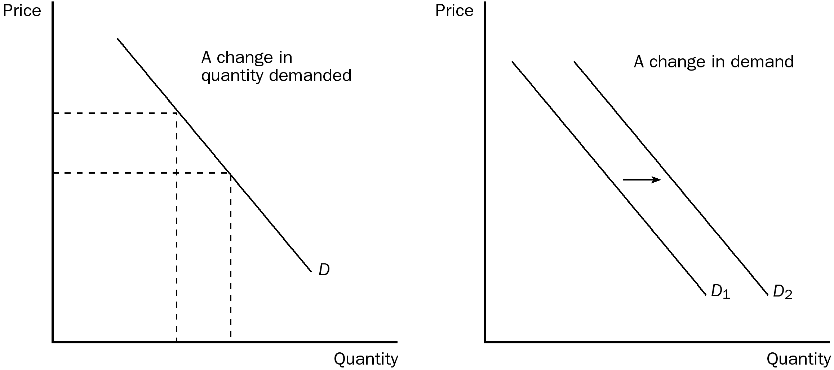

b. A change in price causes a change in quantity demanded. All of the other changes listed shift the demand curve.
TYPE: S SECTION: 2
3. a. What is the difference between a “change in supply” and a “change in quantity supplied”? Graph your answer.
b. For each of the following changes, determine whether there will be a change in quantity supplied or a change in supply.
a. a change in the resource cost
b. a change in producer expectations
c. a change in price
d. a change in technology
e. the number of sellers
ANSWER:
a. A change in supply refers to a shift in the supply curve. A change in quantity supplied refers to a movement along a fixed supply curve.

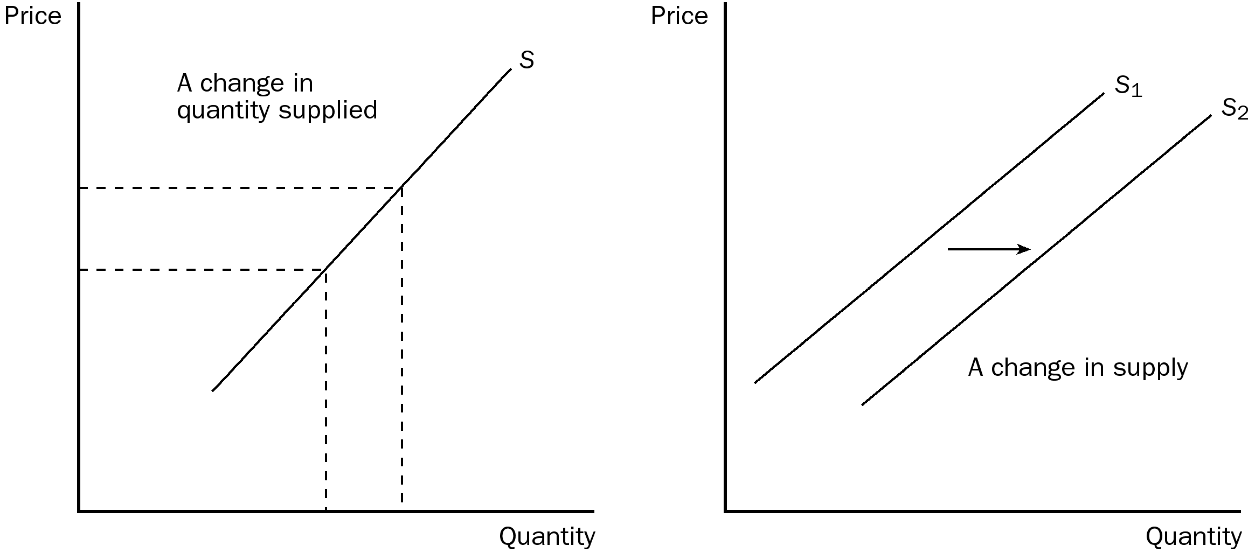

ANSWER: A change in price causes a change in quantity supplied. All of the other changes listed shift the supply curve.
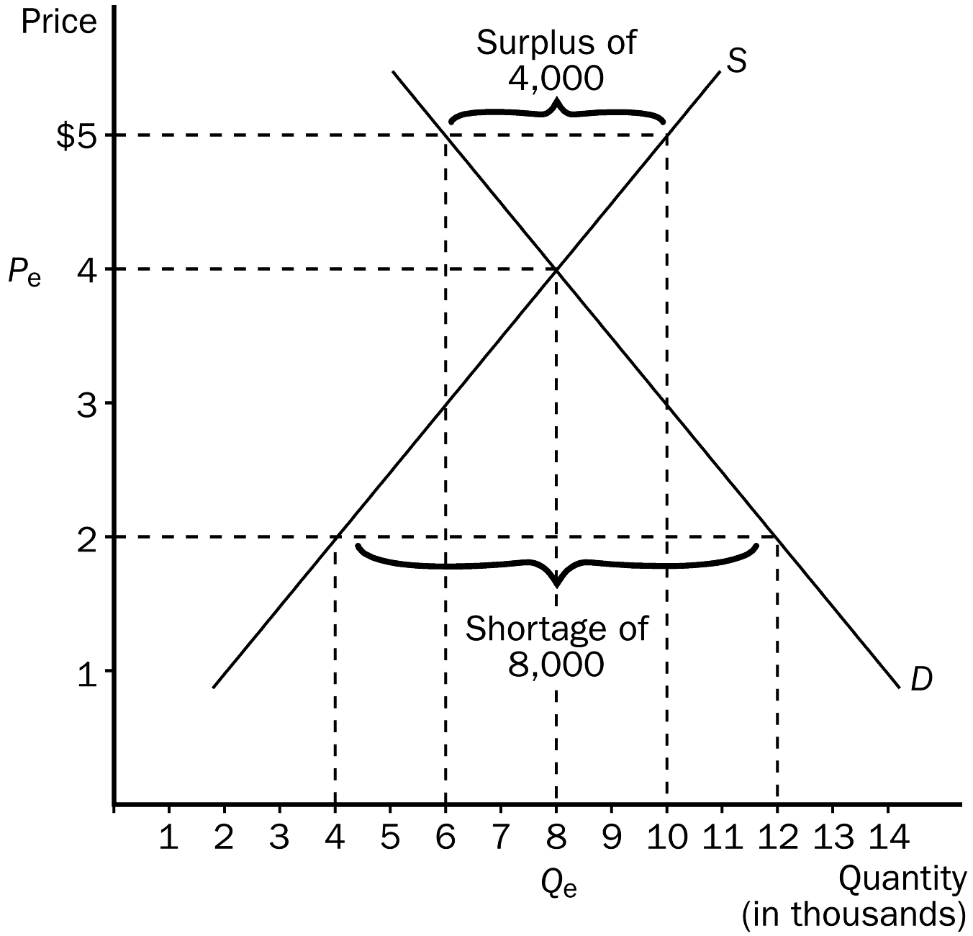
TYPE: S SECTION: 3
4. This question deals with demand and supply and refers you to the table below.
a. Given the table, graph the demand and supply curves for flashlights. Make certain to label equilibrium price and equilibrium quantity.

Price | Quantity Demanded/Month | Quantity Supplied/Month
$5 | 6,000 | 10,000
$4 | 8,000 | 8,000
$3 | 10,000 | 6,000
$2 | 12,000 | 4,000
$1 | 14,000 | 2,000

b. What is the equilibrium price and equilibrium quantity?
c. Suppose the price is currently at $5. What problem would exist in the economy? What would you expect to happen to price? Show this on your graph.
d. Suppose the price is currently $2. What problem exists in the economy? What would you expect to happen to price? Show this on your graph.
ANSWER:
a. see graph.
b. Equilibrium price would be $4 and equilibrium quantity would be 8,000.
c. A surplus of 4,000 flashlights would be the problem in the economy and we would expect the price to fall.
d. A shortage of 8,000 flashlights would be the problem in the economy and we would expect the price to rise.
TYPE: S SECTION: 4
5. Fill in the accompanying table, showing whether equilibrium price and equilibrium quantity go up, down or stay the same.

 | No Change in Supply | An Increase in Supply | A Decrease in Supply
No Change in Demand
An Increase in Demand
A Decrease in Demand

ANSWER:
 | No Change in Supply | An Increase in Supply | A Decrease in Supply
No Change in Demand | P same  Q same | P down  Q up | P up  Q down
An Increase in Demand | P up  Q up | P ambiguous  Q up | P up  Q ambiguous
A Decrease in Demand | P down  Q down | P down  Q ambiguous | P ambiguous  Q Down

TYPE: S SECTION: 4
6. Suppose we are analyzing the market for hot chocolate. Graphically illustrate the impact each of the following would have on demand or supply. Also show how equilibrium price and quantity have changed.
a. Winter starts and the weather turns sharply colder.
b. The price of tea, a substitute for hot chocolate, falls.
c. The price of cocoa beans decreases.
d. The price of whipped cream falls.
e. A better method of harvesting cocoa beans is introduced.
f. The Surgeon General of the U.S. announces that hot chocolate cures acne.
g. Protesting farmers dump millions of gallons of milk, causing the price of milk to rise.
h. Consumer income falls because of a recession and hot chocolate is considered a normal good.
i. Producers expect the price of hot chocolate to increase next month.
j. Currently, the price of hot chocolate is $0.50 per cup above equilibrium.
ANSWER:

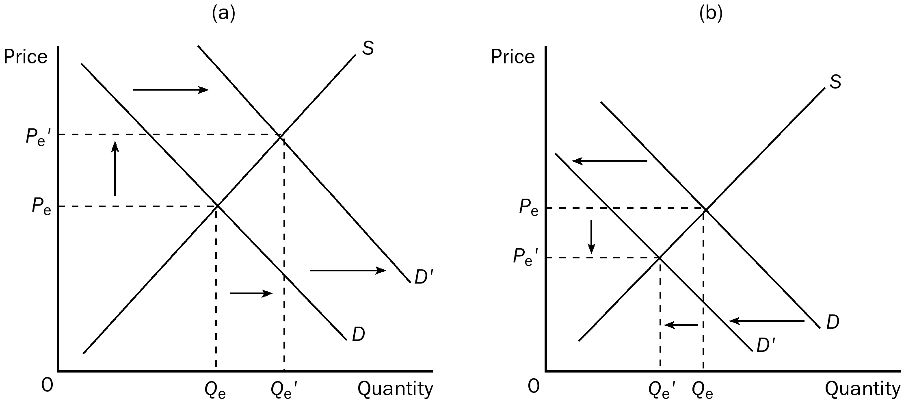

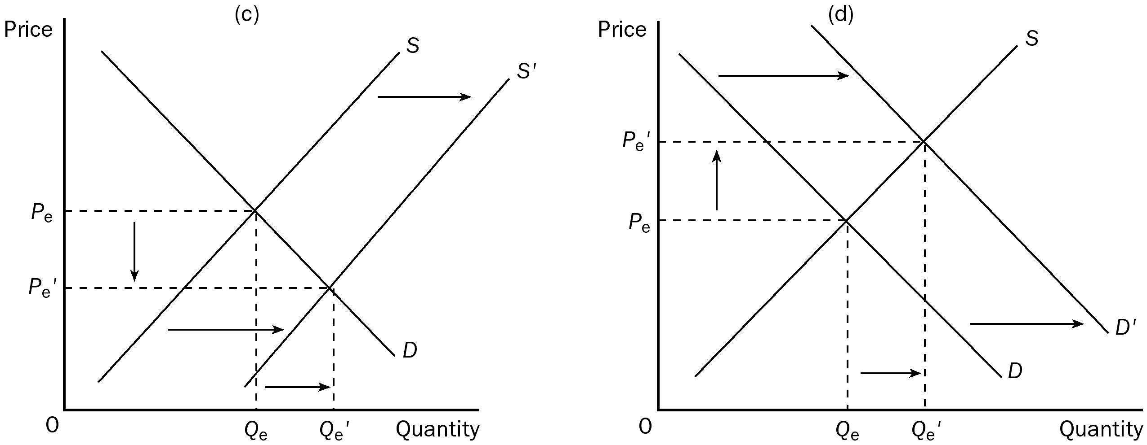

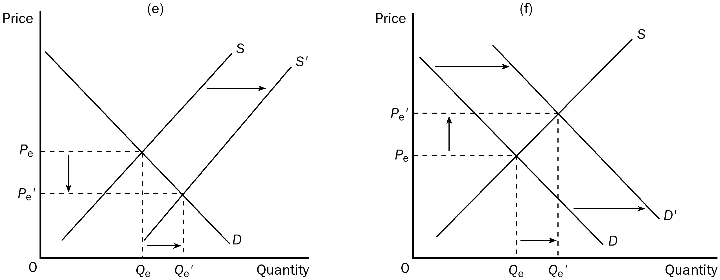

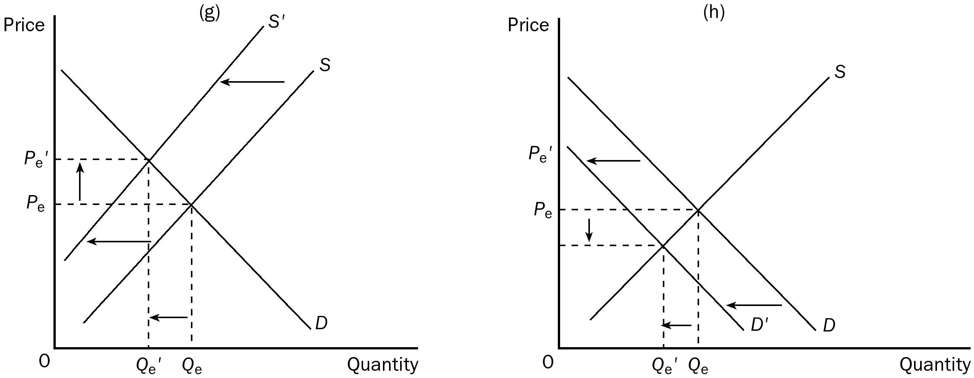

TYPE: S SECTION: 4

